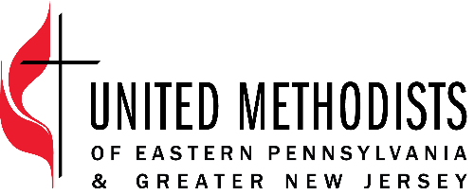

The United Methodist Church forms disciples of Jesus Christ who, empowered by the Holy Spirit, love boldly, serve joyfully, and lead courageously.

Title: Resource Administrator
Classification: Non-Exempt
Band Description: Administrative
Supervisor: Resource Manager

Position Summary
The Resource Administrator provides vital support in various program areas of our affiliated work between EPA (Eastern Pennsylvania) and GNJ (Greater New Jersey) Conferences. The position assists the Resource Manager by providing administrative support so that activities are completed on time, within budget and with excellence. This position is part of the Connectional Ministries Team and the Leadership Development Team and provides support to both teams as assigned, with a focus on Leadership Development.

Essential Functions
- Support the Leadership Development and Connectional Ministries teams with administrative tasks including but not limited to the coordination of logistics, registration, and accommodations for events, trainings, workshops, and meetings so that radical hospitality is provided to clergy, laity, board/agency members and so that external training vendors and directors can provide excellent leadership development initiatives for laity and clergy.
- Support the Lay Servant/Christ Servant Ministry, Local Pastor School, Certified Lay Ministry, and other ministry areas as assigned with administrative tasks including coordination with facilitators, registrations, working with Communications on website and marketing, working with instructors, and updating records in Arena.
- Support Leadership Academy by setting up and maintaining all registrations for courses and resourcing events, both in person and online. Provide support on the Teachable learning platform with setting up courses and tracking enrollments.
- Report monthly on the progress of the Leadership Academy through data collection and synthesis so that the Leadership Development team can effectively respond to the needs of EPA&GNJ.
- Provide support, as needed, for EPA’s Board of Ordained Ministry (BOOM) and related District Committees on Ministry (DCOM). This includes working with DCOM and BOOM to develop and maintain a system for the secure storage of files and granting access to the appropriate persons as BOOM and DCOM leadership shifts/as candidates for ministry move through their processes.
- Maintain electronic files and databases including Arena and internal drives so that all information is current, relevant, and accessible. This includes specifically updating Arena with relationships for Pathways and Journey of Hope resourcing.

Organization Responsibilities
- Serve as a participant or as a project manager for projects as assigned
- Attend and assist in EPA and GNJ meetings and events as needed and appropriate

Core Competencies
- Committed to continuously grow in intercultural competence
- Build and maintain relationships that are rooted in honesty, integrity and honor confidentiality
- Work cooperatively with others to produce innovative solutions.
- Communicate clearly and accurately, in writing and orally, with unifying messages that motivate people to action
- Attention to details and deadlines
- Provide gracious hospitality
Qualifications
- Three or more years in an office or similar work environment
- Competent and skilled in Microsoft Office and Adobe Acrobat

Education
- High school degree with some college or related experience

Travel
- The position requires some evening and weekend responsibilities and some travel beyond the office.
- The position works from the main offices located in Norristown, PA and Neptune, NJ in a hybrid model.

Employee Name:

Employee Signature:

Date:

Supervisor Name:

Supervisor Signature:

Date:

