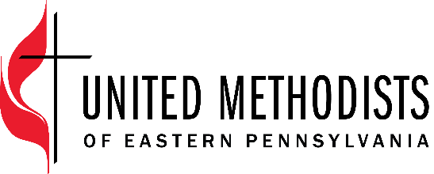

The United Methodist Church forms disciples of Jesus Christ who, empowered by the Holy Spirit, love boldly, serve joyfully, and lead courageously in local communities and worldwide connections.

Title: Director of Pocono Plateau Camp & Retreat Center
Classification: Exempt (Housing provided on site)
Starting Salary: $55,000
Supervisor: Executive Director of Connectional Ministries

Position Summary
The Director of Pocono Plateau Camp and Retreat Center will drive the mission and vision set forth by the Eastern Pennsylvania Conference of The United Methodist Church. The Director will provide visionary leadership, strategic direction, and operational oversight to ensure the successful implementation of programs and initiatives. This position will work closely with the Camp & Retreat Board, Site Committee, and staff to foster a vibrant and nurturing community, managing resources effectively, and ensuring exceptional camper and guest experiences for all.

Essential Functions
- Develop and articulate a vision for Pocono Plateau aligned with the EPA UMC mission and values. Provide inspirational leadership to staff and volunteers, fostering a culture of collaboration, innovation, and excellence.
- Oversee the development, implementation, and evaluation of diverse and engaging camp and retreat programs that cater to various age groups, interests, and spiritual needs. Ensure programs are designed to promote personal and spiritual growth, environmental stewardship, community building, and leadership development.
- Develop and manage the annual budget, monitor financial performance, and implement effective fundraising strategies to support the organization's mission. Identify grant opportunities, cultivate donor relationships, and diversify revenue streams.
- Cultivate and maintain positive relationships with campers, guests, families, volunteers, donors, churches, and community partners. Effectively communicate the impact of the camp and retreat ministry to stakeholders through various channels.
- Oversee paid and volunteer staff to provide facility management, staff recruitment and training, program logistics, and safety protocols. Ensure compliance with local, state, government regulations and ACA standards.
- Work collaboratively with the Site Committee and Camp & Retreat Board to develop and execute strategic plans and masterplans that enhance the organization's reach, impact, and sustainability. Provide regular updates on progress and challenges.
- Establish and monitor key performance indicators to assess the effectiveness of programs and initiatives. Use data and feedback to continuously improve the quality of services and participant experiences.

Core Competencies
- Committed to continuously grow in intercultural competence.
- Build and maintain relationships that are rooted in honesty, integrity, and honor confidentiality.
- Work cooperatively with others to produce innovative solutions.
- Communicate clearly and accurately, in writing and orally, with unifying messages that motivate people to action.
- Attention to details and deadlines.
- Inspire and influence teams to achieve challenging goals and positive results.
- Understanding complex systems and organizations and leading people through change, disruption, and difference.

Qualification
- Five or more years of experience in camp management, youth development, or a similar leadership role.
- Strong organizational and leadership skills.
- Excellent communication and interpersonal abilities.
- Fundraising and grant-writing experience preferred.

Education
Bachelor’s degree or five or more experience in related field (education, outdoor recreation, nonprofit management)

Travel
The position may require some travel outside the region. The position works from the main office located in Pocono Plateau Camp and Retreat Center.

Employee Name:

Employee Signature: _____________________________________________

Date: ________________________________

Supervisor Name:

Supervisor Signature: _____________________________________________

Date: _________________________________

