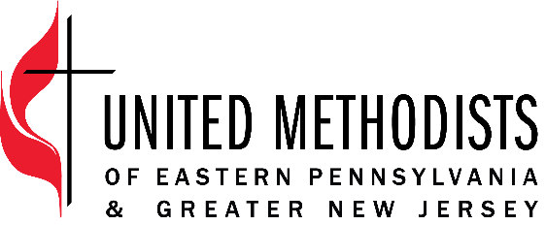

The United Methodist Church forms disciples of Jesus Christ who, empowered by the Holy Spirit, love boldly, serve joyfully, and lead courageously in local communities and worldwide connections.

Title: Creative Consultant of Pathways Bridges Program
Classification: Consultant (Part-Time, 5 hours/week + Coaching Expectations)
Supervisor: Director of Pathways Bridges Program

Pathways Bridges Program
A program to creatively motivate leaders, and congregations to connect and engage with a diverse group of people in their communities through storytelling and spiritual practices. The program bridges the gap between the demographics of the church and those of the broader community, ultimately seeking to ensure that the congregation reflects the diversity of its surroundings

Position Summary
The Creative Consultant will be included throughout our program to offer creative experiences (i.e. music, art, movement, or other creative expressions) to assist with creating a high energy gathering that engages different types of learners.
Essential Functions
- Design and implement creative elements connected to the theme for each of the four in-person gatherings – hospitality, storytelling, pastors retreat, and innovation.
- Collaborate with Director and Program Coordinator to develop scripts, guides, and secure resources to support program activities and church engagement.
- Be present and involved in facilitation at each of the four in-person gatherings along with quarterly meetings with the Director.
- Design and post creative and engaging content to the Pathways Bridges social media accounts 2-3 times per week.
- Serve as a Pathways Bridges Coach to enhance understanding of the cohort.
- Oversee up to 3 congregations and pastoral small groups.
- Equip church teams through two virtual group coaching sessions (1.5 hours each).
- Lead a 2.5 – 4-hour session on community engagement at each local church for their unique contexts.
- Implement creative and innovative activities and approaches for pastors and congregations.
- Collaborate with Director and Program Coordinator to develop scripts, guides, and secure resources to support program activities and church engagement.

Core Competencies
- Committed to continuously grow in intercultural competence.
- Build and maintain relationships that are rooted in honesty, integrity and honor confidentiality.
- Creative thinking and ability to effectively develop imaginative and innovative ideas.
- Work cooperatively with others to produce innovative solutions.
- Communicate clearly and accurately, in writing and orally, with unifying messages that motivate people to action.
- Attention to details and deadlines.

Qualification
- Experience creating resources, presenting, and facilitating diverse groups.
- Experience curating an engaging social media presence (i.e. Facebook, Instagram, etc.)
- Coaching Training or equivalent experience and skills
Travel
Travel within EPA&GNJ will be required for Pathways Bridges cohort gatherings. Travel reimbursement is included in the annual stipend.

Start date: June 1, 2026
End Date: May 31, 2027

*Two additional coaching sessions for each of your congregations in June & October 2027

Annual stipend: $12,625 (payments of $1,052.08 per month)

Employee Name:

Employee Signature: _____________________________________ Date: ____________________

Supervisor Name: Alyssa Ruch

Supervisor Signature: _____________________________________ Date: ____________________

