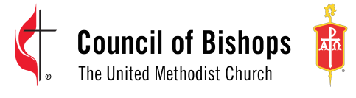
110 Maryland Avenue NE, Suite 301 | Washington, DC 20002 | 202-547-6270

United Methodist Ecumenical and Interreligious Training: Plunge (UMEIT: Plunge)

REGISTRATION FORM
The UMEIT: Plunge is the creation of Bishop Sudarshana Devadhar, who believed United Methodists could best learn about the global Ecumenical Movement by immersing themselves amongst the leadership of the Movement and through personal engagement. The Plunge takes place once a quadrennium. It is a two-week commitment and the cost per person is $4,000 US. All United Methodists are welcome to participate. The 2026 Plunge will take place August 18th through 31st in Switzerland and France. All participants need to send in this registration form no later than April 18th to jhawxhurst@umc-cob.org.

Name is it appears on Passport: ____________________________________________________

Passport Number: ____________________________ Expiration Date: ________________

Home address: _________________________________________________________________

______________________________________________________________________________

Departure and Arrival Airport: _____________________________________________________

Phone number: _______________________________

Email address: ________________________________

Date $4,000 US received in COB office: ______________________________________________

Please name any food allergies or issues: ____________________________________________

______________________________________________________________________________

Please name any mobility issues: __________________________________________________

Name of person traveling with you if applicable: ______________________________________

Would you like to room with that person? ___________________

Insurance information: __________________________________________________________

