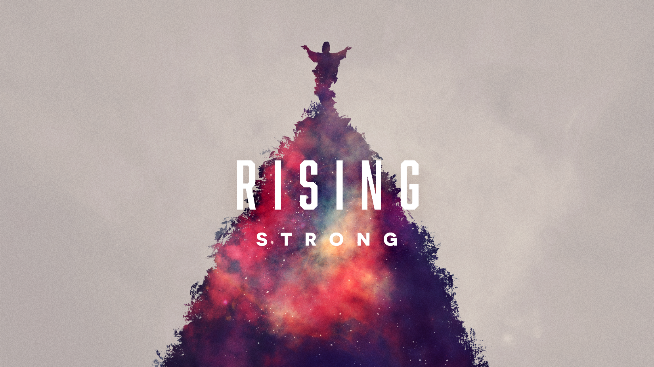
Rising Strong

Small Groups

Week 1 Small Group: Rising from Skepticism (Thomas)

OPENING PRAYER:
Ever-present Lord, open our hearts and minds to your wisdom as we study the Scriptures. As we open ourselves up to you and to each other, guide us from where we are to where you are leading us. Whatever skepticism we may be holding on to, guide us to be patient with ourselves as we prepare to experience your presence, love, and grace. Amen.

Quote:
“Do not let yourselves become tainted by a barren skepticism.” - Louis Pasteur

BREAKING THE ICE:
Share a story about something that has happened to you that seemed unbelievable at the time.

WRESTLING WITH THE WORD:

Read John 20: 24-28
- Why do you think Thomas was skeptical? What might have caused him to question what the disciples had told him?
- Verse 26 reads: “A week later his disciples were again in the house, and Thomas was with them. Although the doors were shut, Jesus came and stood among them and said, ‘Peace be with you.’” What do you think Thomas was wrestling with during that week between what the disciples had told him and actually seeing Jesus?
- The passage never specifies if Thomas actually touched Jesus’ wounds. If Thomas no longer needed the proof, what do you think led Thomas to rise from skepticism into belief?

NEXT STEPS:
- When have you ever been skeptical of God’s promises? Did you/how did you give yourself time to wrestle with that skepticism?
- What kind of experience do you need to have in order to rise from skepticism to belief?
- Has anyone ever been skeptical towards you when you shared your faith? How did you handle it?

CLOSING PRAYER:
God of Miracles, remind us how faith in the Risen Christ can transform our lives for the better, here and now. Stretch out your hands and raise us up from doubt, denial, hatred, and fighting. Fill us with the strength of your Spirit, so that we may rise strong. May our journey as a Resurrection people bring light to the world. Amen.

Week 2 Small Group: Rising from Denial (Peter)

OPENING PRAYER:
God of Love, remind us this day of the immense power we find in the words of the Risen Christ. May we follow the light of Jesus through the darkness of our denial and be guided into open and loving receptiveness. Through your grace and guidance, may we feed your sheep with peace and hope. In the name of Christ we pray. Amen.

Quote:
“Denial ain't just a river in Egypt.” - Mark Twain

BREAKING THE ICE:
Name something you were once in denial about that you now accept.

WRESTLING WITH THE WORD:

Read John 21:15-19
- In Mark 14:66-72, Peter denies Jesus while Jesus is on trial. Why do you think Peter denied Jesus at this moment?
- In the John 21 passage we read today, how many times did Jesus question Peter? Do you think this is significant? Why or why not?
- Perhaps rising from our denial entails rising from our guilt. How do you think this conversation between Jesus and Peter guided Peter out of his denial?

NEXT STEPS:
- Where do we see denial in our lives, our culture, and even our congregations? How can we use the example of Jesus from this passage to help guide ourselves and others from denial to acceptance?
- Have you ever denied Jesus or harbored guilt that holds you back from him?
- How can the love of Jesus raise us up from the darkness of denial to the light of caring for others, or in Jesus’ words, tending to his sheep?

CLOSING PRAYER:
God of Miracles, remind us how faith in the Risen Christ can transform our lives for the better, here and now. Stretch out your hands and raise us up from doubt, denial, hatred, and fighting. Fill us with the strength of your Spirit, so that we may rise strong. May our journey as a Resurrection people bring light to the world. Amen.

Week 3 Small Group: Rising from Hatred (Saul/Paul)

OPENING PRAYER:
Transformative God, we gather to study what you have to say to us through the Scriptures and to grow together as we learn about Saul and Ananias. Through this passage, open up our hearts to understand what it means to be faithful and how we, as your children, can move from our own hatred into faithful, loving service. Amen.

Quote:
“Returning hate for hate multiplies hate, adding deeper darkness to a night already devoid of stars. Darkness cannot drive out darkness; only light can do that. Hate cannot drive out hate; only love can do that.” - The Rev. Dr. Martin Luther King Jr.

BREAKING THE ICE:
Name a type of food you hate.

WRESTLING WITH THE WORD:

Read Acts 9:1-22
- What do you think was Saul’s motivation for persecuting the early believers?
- Why do you think God chose to use someone like Saul, apparently filled with incredible hatred towards Christ-followers, as an instrument to spread the Good News?
- Just as Saul seemingly had hatred toward Christ-followers, how do you think a Christ-follower like Ananias felt toward Saul? What do Ananias’ actions, when asked in the passage to heal Saul, suggest about his feelings toward him?
- How does Ananias’ ability to rise above his own feelings of hatred toward Saul encourage Saul to move beyond his own hate and live into God’s purpose?

NEXT STEPS:
- How can you encourage people in your life who may be living in judgment and fear to respond to God’s call?
- How can we listen for God’s truth about others instead of prioritizing our own opinions?
- Consider Jesus’ question to Saul asking, “Why do you persecute me?” and Jesus’ words in Matthew 25:40: “Truly I tell you, just as you did it to one of the least of these brothers and sisters of mine, you did it to me.” What is the relationship between these two sayings of Jesus – for Saul? For you? For us?

CLOSING PRAYER:
God of Miracles, remind us how faith in the Risen Christ can transform our lives for the better, here and now. Stretch out your hands and raise us up from doubt, denial, hatred, and fighting. Fill us with the strength of your Spirit, so that we may rise strong. May our journey as a Resurrection people bring light to the world. Amen.

Week 4 Small Group: Rising from Quarreling (The Church)

OPENING PRAYER:
God of Peace, open our hearts this day to the example of your grace which calls us from places of conflict and dissension to being people and communities that are united in your love despite our disagreements. Fill this space and our discussion with your Holy Spirit, so that we may reflect for the world the ways in which your wisdom can guide us and raise us from our deepest moments of strife to our greatest moments of opportunity. Be with us now, we pray. Amen.

Quote:
“When you have a conflict, that means that there are truths that have to be addressed on each side of the conflict. And when you have a conflict, then it's an educational process to try to resolve the conflict. And to resolve that, you have to get people on both sides of the conflict involved so that they can dialogue.” - Dolores Huerta

BREAKING THE ICE:
Are you a fight or flight person? Do you engage in or try to avoid conflict at all costs?

WRESTLING WITH THE WORD:

Read Acts 15:1-21
- Who are the different parties quarreling in this passage? What is the matter at hand and what is at stake?
- How do the elders and apostles in the passage work through their differences to come to a sense of unity?
- Are the Gentiles present in this passage and what role do they play?

NEXT STEPS:
- What characteristics of God do the parties in the passage model for us to use to rise above our own conflict and quarreling?
- How often do we quarrel about people or groups of people (just like the Gentiles in the passage) who aren’t invited to the table to have a voice in the conversation? How can we, as people of faith, work harder to include those voices that have been silenced?
- What is the difference between unity and uniformity? In a world where unity seems impossible, how can we rise strong and use the example of God’s grace as a tool to unite others through conflict?

CLOSING PRAYER:
God of Miracles, remind us how faith in the Risen Christ can transform our lives for the better, here and now. Stretch out your hands and raise us up from doubt, denial, hatred, and fighting. Fill us with the strength of your Spirit, so that we may rise strong. May our journey as a Resurrection people bring light to the world. Amen.

