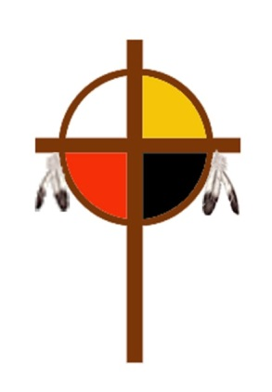
EPA CONFERENCE CONAM PRESENTS
WE ARE STILL HERE
OUTSTANDING NATIVE AMERICANS TODAY
A Zoom Presentation – MAY 2, 2021 AT 4 PM
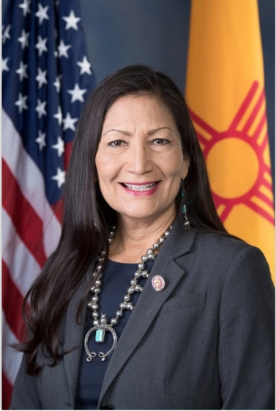
The First People of the land are still here. They live on reservations, in urban areas and in the countryside. You will find them in business, in the U.S. government, in cultural endeavors and all professions.
We honor them and celebrate the rich heritage of a wealth of understanding about the natural world and how we live together in a community that honors each person and their gifts.
They continue to give today in many ways.
REGISTRATION LINK: https://na.eventscloud.com/still-here
Sponsored by EPA Conference Committee on Native American Ministries. Learn more at
https://www.epaumc.org/connectional-ministries/advocacy/racial-ethnic/native-american/

