A Miracle Is in the Midst!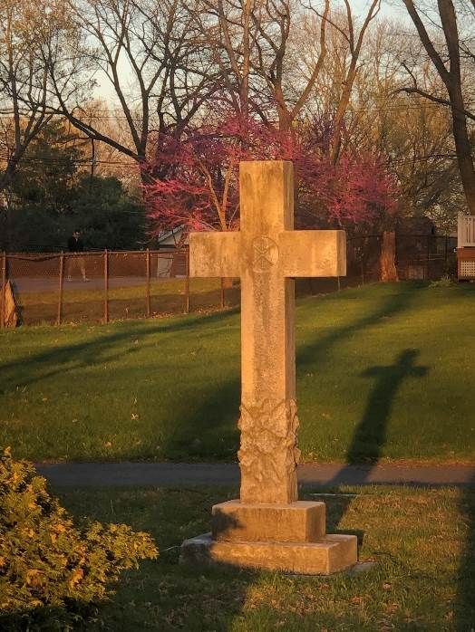
Easter 2021

“What shall we say then? Are we to continue in sin that grace may abound? By no means! How can we who died to sin still live in it? Do you not know that all of us who have been baptized into Christ Jesus were baptized into his death? We were buried therefore with him by baptism into death, so that as Christ was raised from the dead by the glory of the Father, we too might walk in newness of life.” Romans 6:1-4

Greetings in the Powerful Name of Jesus Christ!

I came across a story that I thought you might enjoy.

A man was looking in a shop window at a beautiful picture of the Crucifixion. Standing next to him was a little boy who was rapt in contemplation of the picture. Wondering if the boy really understood it, the man asked, “Sonny, what does it mean?”
“Doncha know?” the boy answered. “That man is Jesus and them others is Roman soldiers, and that woman that’s cryin’ is his mother, and – they killed him.” The man turned away, and in a moment heard the pattering of footsteps behind him. “Say, mister, I forgot to tell you the most important part. He rose again!”

I think the boy has the story right. Jesus rose again! However, its real meaning and power comes when the story dwells in us and comes alive through us! How that happens is the point of Paul’s words above from Romans chapter 6.
If you only glanced at the words before, please take a moment and read them a bit more closely now. Go ahead…I’ll wait for you here!
Christ truly died for us! And through our baptism, we died with him! We have surrendered all that we have to him. We have died, Paul continues, so that “we might no longer be enslaved to sin.” This is not to say that we will never sin again, but that we are no longer controlled by the power of sin. We are under the dominion of Christ rather than the gods of this world.
In three days, “Christ was raised from the dead by the glory of the Father.” Just as we have died with Christ through our baptism, we also are resurrected! We “walk in newness of life” as new creations! We have a new desire, a new purpose – to serve our Lord Jesus Christ – and a new assuring hope – eternal life.
While Easter is a special occasion that we celebrate once a year, it is really an event we should celebrate every day. As we live in Christ, we experience him and the power of his resurrection in all that we are and all that we do. We are blessed to have every aspect of our lives anointed by the good news that has been proclaimed in the light streaming from the empty tomb.
We embrace the miracle that happened that day and relish those times when we are reminded of it again. Miracles can manifest themselves in many ways, and we have seen this throughout the past year as you have dug deep into your souls to help others through trauma, uncertainty and heartache. A leader helping to facilitate this has been the Miracles Everywhere Campaign that provided over a million dollars in 2020 to those impacted by the pandemic. Now in the last year of the campaign, we hope you can contribute to this worthy cause so we can continue to do what Jesus did and be part of making miracles come true.

With Easter Joy,
Pastor

