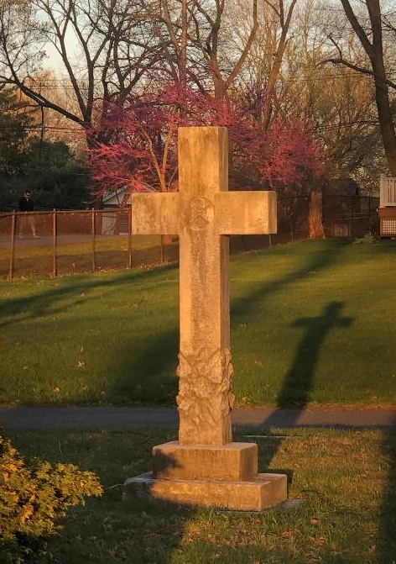
He Is Risen Indeed!

Easter 2021

“For I am sure that neither death nor life nor angels nor principalities nor powers nor height nor depth nor anything else in all of creation will be able separate us from the love of God in Christ Jesus our Lord.” Romans 8:38-9

“And the angels said to the women, ‘Why do you seek the living among the dead? He is not here, but has risen.’” Luke 24:5

Greetings in Jesus’ Name!

One Friday night in April 2005, Ming Kuang Chen went out to make a delivery for Happy Dragon restaurant. It was to a high-rise apartment building in Bronx, New York. About 8:30 p.m., after making three deliveries in the complex, he vanished.
The New York Police Department conducted a massive search. Days passed. Hope waned for finding the 35-year-old immigrant from southeastern China. Speculation grew that Chen was the victim of armed bandits or some other urban horror.
Three days later, at about 5 a.m., police responded to an emergency call at the high-rise in the Bedford Park neighborhood. There, in an elevator stuck between floors, firefighters pulled Chen out – alive!
Apparently, Chen had entered the elevator on the 32nd floor when it plunged down and got stuck between the third and fourth floors. He knocked on the door and screamed for help, but to no avail. In the end, he emerged thirsty and hungry, but alive…and thanking everyone for caring about him.

A resurrection moment! An Easter moment! An alleluia moment!

On Good Friday, the followers of Jesus had watched him die on Calvary. After three days, their hope too had died. But, in the end, Jesus emerged…alive! God’s response to the evil and suffering of the cross was not to come charging in to rescue him, but to bring new life…even out of death.
God did not prevent Good Friday, but God transformed it into Easter. For us who live in a world of Good Fridays, this is the Good News. Our Good Friday will be transformed into Easter. Our times trapped in the elevators of life, our times beset by the pressures and struggles of living, our times smothered by the pain of illness or heartache or despair will be transformed into new life. We are assured that God, who created and loves us, is at work to help us overcome the very worst that can happen.
Just as God wouldn’t allow death to be the end for Jesus, so God will not allow it to be the end for us either. We know that nothing, not even death itself, has the power to put us beyond the reach of God’s love. God is with us…always. In this we have hope. In this we have faith. In this we have life.

From dusk to dawn, from start to finish, from death to life, from the cross to heaven…Jesus is risen!

In Christ Always,
Pastor

