Greater New Jersey Annual Conference 2020
Participants Guide

What to know before you register:
- Only voting members will be allowed to participate in the sessions via Zoom video, dial in or limited in person gatherings. Credentials will be confirmed for each voting member upon submitting their registration. REGISTRATION FOR ANNUAL CONFERENCE CLOSES ON SEPTEMBER 30. If you are not registered by September 30 you will not be able to vote or speak at the annual conference session but only view the annual conference session on YouTube.
- Guests and visitors are invited to participate by watching the sessions live on YouTube at https://www.youtube.com/GNJUMC. Guests and visitors should not pre-register. Guests and visitors will be able to view the annual conference session on GNJ’s YouTube by going to www.gnjumc.org/2020annualconference and selecting the link for visitors to the 2020 GNJ annual conference session.
- If your household has two or more voting members, you will need to register separately and use different devices (phones, computers or tablets) to participate and vote.
- Each voting member can participate by using one device only. You cannot log in on your phone and your computer, for example. It is essential that people in the same household use different accounts to register and that they log on with two devices. Each Zoom link for video and phone is unique and cannot be shared with others.
- If you are registering by push-button dial-in phone (not a smartphone), you must call in using the same number you include in the registration so that your credentials can be matched and verified.
- Limited in-person gatherings are available for those who need accommodation for technology or American Sign Language. Because of social distance requirements, only pre-registered voting members will be allowed to join at these sites. Guests and visitors will not be admitted.
- For those registering for Zoom video (those using a computer, tablet such as iPad or smartphone such as an iPhone or Android phone): An email confirming your credentials and Zoom registration will be sent within 2 business days after you register. Be sure to check your junk mail, if you do not receive the confirmation within two days.
- For those registering for Zoom dial in (those using a push button phone): You will receive your credentials and dial in information the week of September 28. You will only be able to join the Zoom meeting by phone if you dial in using the same phone number that you included with your registration.
How to join the Annual Conference virtual session
- For members who registered for Zoom Video Session
- The registration confirmation email will be sent to you within 2 business days.
- Open the confirmation email with the title “[CONFIRMATION] 2020 GNJ Annual Conference Virtual Session Registration”
- In the email, click “Click Here to Join”
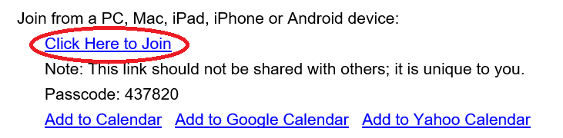

- We strongly encourage all participants on Zoom Video that you give yourself enough time to join the meeting before the daily session starts so that you can ensure the technology and your internet connection work properly. The Annual Conference Session is available to join at 8:30 a.m. on Monday, October 5, and 8:00 a.m. on Tuesday, October 6.

- Please ensure that Zoom is already installed on your device and is up-to-date. This is very important as you may have issues voting or joining the Session if you do not have the latest version of Zoom. Even if your regular Zoom meeting works well, the Zoom webinar may not function properly if you do not have the latest version of Zoom.

How do I check if the Zoom on my device is up-to-date?
- If you have a Zoom account, refer to Zoom support page (https://support.zoom.us/hc/en-us/articles/201362233-Upgrade-update-to-the-latest-version) to learn how to check for updates.
- If you DON’T have a Zoom account, uninstall Zoom, download the newest version of Zoom from the website (https://zoom.us/download) and re-install it.

- Check your junk email folder first if you cannot locate the Confirmation email. If you are still unable to locate the email, contact Soomin Lee at slee@gnjumc.org.

- For members who registered for Dial In
- The Dial-in info will be sent to your email prior to the Annual Conference
- Use the Dial-in number and enter Webinar ID and press the # key

- Make sure to use the same number that you have registered with. Otherwise you may be removed from the meeting.
Having technical issues with joining the Annual Conference?

TEXT (201) 870-1648 with your name and the issue you are having (e.g., “John Smith, can’t locate confirmation email”)

Voting process during legislation session
- Bishop invites participants to click “Raise hand” to cast a vote
- Participants vote by clicking “Raise Hand” or pressing *9
- Bishop announces the result of the vote
- All votes are cleared for the next voting

How to use “Raise Hand” feature on your device
- For members using a computer (Windows or Apple operating system):
- Hover your cursor to the bottom of the Zoom Webinar screen and find Raise Hand icon.
- Click on the Raise Hand only one time and the hand will turn blue.
- Once you select the raised hand, there is nothing more you will need to do. Selecting or deselecting the hand feature again will eliminate your vote and it will not be counted.

- For members using a smartphone or tablet:
- Tap the screen and find Raise Hand on the bottom of your screen.
- Touch Raise hand and you’re the hand icon will turn blue.
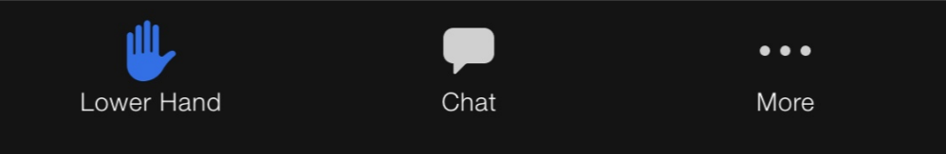

- Once you have raised your hand, there is nothing more you will need to do.

- For Members using a push-button phone and the Zoom Dial in
- Once Bishop announces the vote, press *9 to Raise Hand

- For Members in-person at Limited Regional Gatherings
- Raise your hand for or against a motion and a proctor on-site will record your vote and relay it to the conference secretary.

- Please click “Raise Hand” only ONCE as clicking the icon twice will lower your hand and your vote will not be counted. You do not need to “Lower Hand” after the vote as Hands will be lowered all at once by the administrators.

- More information about Raise Hand feature can be found on Zoom website or https://support.zoom.us/hc/en-us/articles/205566129-Raising-your-hand-in-a-webinar

Speaking during legislation session
- For Members on Zoom Video
The Zoom chat function will be open during the legislation session and may only be used for indicating you would like to speak during the session. Members who make remarks will be removed from Zoom and will be unable to rejoin the session. This is because the chat feature is being used to facilitate the annual conference session.
You may only use the chat to request permission to make a speech for, a speech against, an amendment or other parliamentary procedure. To request to speak, type the number listed below.
Type 1 for a speech for legislation
Type 2 for a speech against legislation
Type 3 to make an amendment and specify your amendment. For example:
- 3 I would like to make an amendment on (specify the amendment)
Type 4 for any other request and specify your request. For example:
- 4 I would like to refer the matter
- 4 I would like to call the question
- 4 I would like to (add any other request)

Type ONLY number for 1 and 2. For 3 and 4, type number FIRST and specify.
How to request to speak on Zoom
- Click Chat and open
- Type the number from above in the chat.
- You will be promoted to a panelist once your turn arrives. A Pop-up screen will appear about allowing host to unmute you. Click Allow and remain on the cue.
- Once it’s your turn to speak, turn on your camera. You will be unmuted by the administrators.
- As your speech is completed, your will be changed to Attendee.

- For Members on Zoom Dial In
- Press *9 to request to speak.
- When you are called to speak, you will be able to unmute yourself by pressing *6 and start speaking.
- You will be muted once your speech is completed.

- Your phone will be muted throughout the session.

- For Members In Person at Limited Regional Gatherings
Raise your hand and a proctor on site will direct you to a computer to speak to the session.

For any questions, please contact Soomin Lee at slee@gnjumc.org

