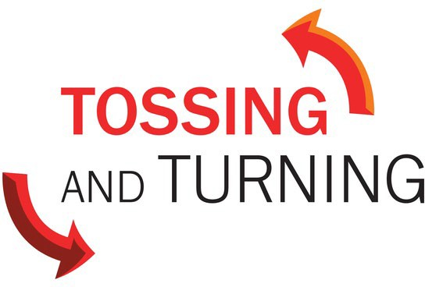
Series Overview

All of us have things that keep us up at night, tossing and turning. What does the future hold for me? Does the Bible even talk about that? Is God too big to worry about my everyday life concerns?

Week 1: Fear
Deuteronomy 31:1-8, Philippians 4:4-9

Fear is a natural response to a threat. All of us wrestle with fears. The good news is that whatever fear we are facing, we never face it alone.

Week 2: The Future
Matthew 6:25-34, Isaiah 41:10-13

We often like to control the future of our lives, so much so that we toss and turn at night. We stress out and worry about things that we can’t control. You may have heard the phrase, “God is in control,” … but what does the Bible say?

Week 3: Finances
Luke 12:16-21, 1 Kings 17:2-16

Financial matters wake us up in the middle of the night and can make us sleepless. The world teaches us we can be free from the anxiety of money when we have more of it. But the Bible says having more doesn’t set us free but being contented does.

Week 4: The Anxiety of Choosing
Jonah 2:1-10, Acts 1:15-17, 21-26

Making a decision can feel like hammering the nails into the coffin of opportunities. We agonize over making the wrong
decision. Whatever decision we make, we can never stray so far that we are beyond God’s redeeming grace.

