The Church of the Master
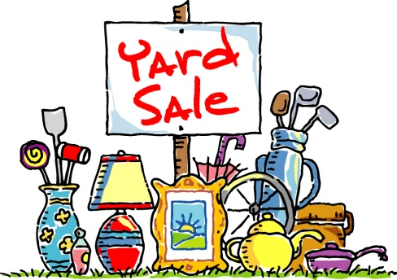
Yard Sale,
Clothing Sale & Bake Sale
SATURDAY, APRIL 13th, 8am-3pm
(Rain Date, April 27th)

110 Salem Hill Road, Howell, NJ

Gently used clothing* for Sale - $5 a bag
* Coats and large items priced separately

Household Items and Treasures for Sale
to benefit the Church and its Missions
Bake Sale – homemade items

FREE COFFEE!

