Greater New Jersey United Methodist Historical Society
Celebrating the 50th Anniversary of The United Methodist Church
with the Reverend Fred Day

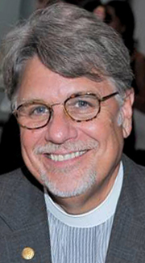
The Greater New Jersey United Methodist Historical Society would like to invite you to attend a special morning presentation by the Reverend Fred Day, General Secretary of the General Commission on Archives and History on September 29, 2018, at the historic Evangelical United Methodist Church in Clarksboro, NJ. Reverend Day’s interactive presentation will be on “Celebrating the 50th Anniversary of The United Methodist Church which is this year’s Heritage Sunday theme. The address to the Evangelical UMC is 14 West Cohawkin Road, Clarksboro, NJ 08020. If you have any questions, please contact Mark Shenise at mshenise@gcah.org or 973-408-3194.

