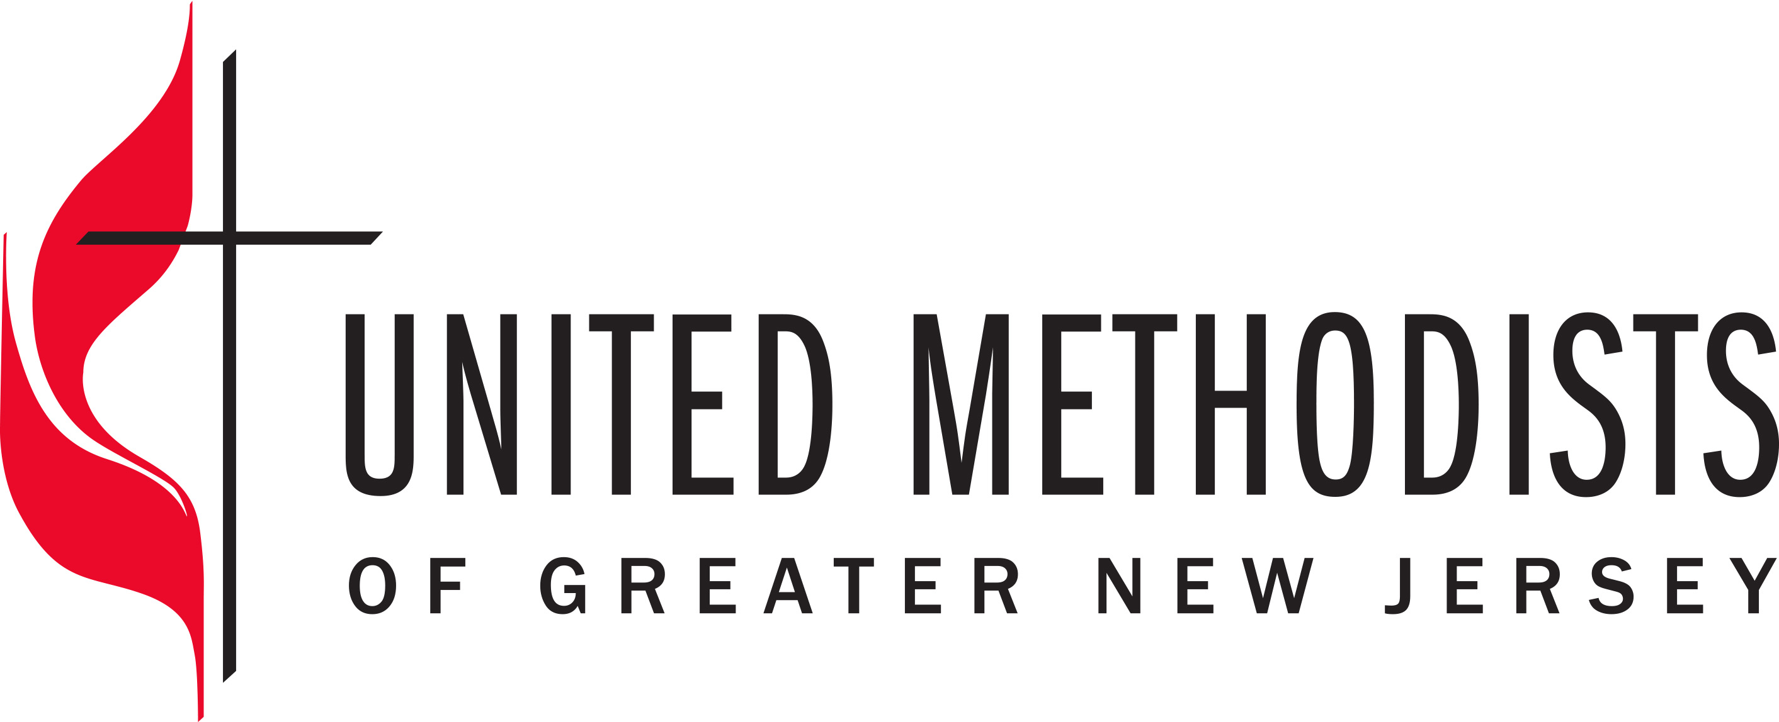

10 Year Intercultural Competence Plan
The 2017 Annual Conference passed a resolution calling for the implementation of a 10-year intercultural competence plan.
Intercultural Competence Plan:
After this I looked, and there before me was a great multitude that no one could count, from every nation, tribe, people and language, standing before the throne and before the Lamb. – Revelation 7:9
Our Purpose
We believe God’s love heals and transforms lives. God’s love is encountered in disciples of Jesus who passionately share faith, hope and justice in the community. Vital congregations form and shape passionate disciples. We recruit and develop transformational leaders to make disciples and grow vital congregations to transform the world.
Our Vision
We see a church like Jesus Christ—radical spirit and humble, teaching and healing, soul saving and soul tending, leader and servant, unbound and outbound. We also see a Wesleyan Church – personal holiness and social holiness, connectional and risk-taking, thoughtful and inspirational, small groups and large vision, welcoming all and respect for diversity of thought.
Our Commitment
Resource and support the development of congregations and lay and clergy transformational leadership. Equipped and vital leaders and congregations are powerful witnesses to the Gospel of Jesus Christ throughout the region.
Purpose of the GNJ Intercultural Competence Plan
Develop the leadership capacity to create a systemic shift in GNJ from diversity to intercultural competence.
Values
These are the values we will honor as we lead GNJ into intercultural competence:
- Christ-like Love
- Trust
- Humility
- Transparency
- Community (Ubuntu)
- Justice
- Accountability
Key Audiences
We will focus on four key segments of the conference leadership:
- Conference Leadership and Staff
- Board on Ordained Ministry
- Laity
- Clergy
* Conference Staff & Leadership includes the Cabinet, GNJ Staff, Board of Laity, elected officers and Vital Mission Partners.
Three Year Goals (by 2021)
We will work with congregations and transformational leaders that are ready and desire to be interculturally competent and Christ-like as they carry out their mission and ministry. Completing the following goals will build a solid foundation for a 10-year commitment of growing intercultural competence in which GNJ’ s values, processes and policies align and develop the leadership capacity needed for a regenerative intercultural competent GNJ.
- GNJ leadership and staff teams will work together, in consultation with GCORR, to assess their level of intercultural competence and receive appropriate training and set strategies that foster intercultural competence in GNJ. This work will target four general groups:
a. Conference leadership
b. Conference staff
c. Connectional Table, Boards of Laity and Ordained Ministry and agencies
d. Vital Mission Partners and Advance Specials
- GNJ Board of Ordained Ministry will work in consultation with GCORR, to develop the knowledge, skills, policies and practices that make intercultural competence a priority for board members, existing clergy and throughout the candidacy process, including but not limited to DCom, RIM, and all other recruitment efforts.
- The GNJ staff leadership team will evaluate GNJ Rules of Order, communications, staff and hiring policies and practices and modify as needed, to reflect the conference commitment to intercultural competence.
- The Connectional Ministries team will identify GNJ bright spots where intercultural competence is best practiced, who then will become teaching congregations and ministries in GNJ and the greater church.
- The Connectional Ministries team will assess current congregational, laity and clergy leadership development resources and evaluations (Team Vital, Coaching, PaCE, Communities of Hope Vital Laity Leadership Development, Lay Servants, Clergy & Congregational Evaluations, etc.) and modify them to incorporate equipping for intercultural competence as needed.
- 100 congregational teams participate in a cross racial/cultural vitality program.
- 200 clergy participate in an intercultural competence development program (to assess & develop knowledge, skills and leadership capacity).
- 100 clergy will participate in a pulpit exchange program.
- 2,000 laity are equipped in cultural competency.
The following metrics will provide us additional measurable indicators about our long-term progress towards a culture of intercultural competence in GNJ. By 2027:
- GNJ racial/ ethnic professing membership increases from 18882 to 19448
- The number of multicultural congregations/faith communities increases from 114 to 175
- GNJ racial/ ethnic active clergy increases from 186 to 204
- GNJ women active clergy increases from 36% to 45%
- Average active clergy age is reduced from 55 to 50
We believe accomplishing these goals and objectives will bear fruitful outcomes that include intercultural competent transformational leadership, radical Christ-like discipleship, vital congregations that includes everyone in the community and reflects the diversity of their ministry context, changed lives and transformed communities.
Next Steps
Phase 2: Detailed Strategic Plan Development | 08/01/2017
- Executive Summary presented/approved by Annual Conference – 05/22/2017
- Create staff project management team – 06/15/2017
- Facilitated work sessions of Task Force and Project Management Team with GCORR Staff. 07/30/2017
- First draft of detailed Strategic Plan and Resource Development planning completed 09/01/2017
- Final detailed Strategic Plan and Resource Development planning completed – 11/01/2017
Phase 3: Implementation of Strategic Plan | 01/2018 – 06/2021
The Cultural Competence Task Force will meet once a year to receive updates from GNJ staff and evaluate progress and then report to Connectional Table and Annual Conference accordingly.
Phase 4: Evaluation | 03/2021
Evaluation, re-calibrating and strategic planning process for the next four years.

