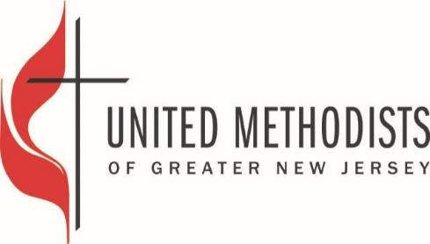
This SAMPLE Lease Agreement – is if the parsonage continues to be used as a parsonage for tax purposes
Parsonage Use Agreement
Between and among: Trustees of Church Name here and renter’s name here

The purpose of this letter is to confirm the understandings regarding (Church name here) United Methodist Church parsonage for the residence of its pastor, (Add Pastor’s Name Here)
1. Effective start date here the Church name here parsonage will be leased by the Trustees of Church name here for $amount here /month to be used by their renter’s name here and his/her immediate family as a residence. Occasional overnight visitors are permitted – but other residents are not.
2. Church name here UMC will pay all utility bills related to the Church name here parsonage (electric, gas, heat, telephone, cable, internet, water, sewer). All bills will be paid by their respective due date.
3. The residents will keep the property clean and in good order. They will put out trash and recycling in accordance with local regulations. No pets are permitted.
a. Lawn care/snow removal will be agreed upon by the Presidents of each board of Trustees.
4. Repairs and maintenance will continue to be the responsibility of the Church name here UMC. Renter’s name here will be responsible for any damage caused by him/her, his/her family or his/her guests. A survey of the property will be made and signed by Renter’s name here and Church name here Trustee representative prior to move in.
5. Church name here UMC’s use of the parsonage shall only be until end date of agreement here in keeping with customary appointment processes. This arrangement is viewed as a one year agreement to be revisited by all parties by March 1, 0000 at which time a new agreement might be considered. ADD THIS ONLY IF APPLICABLE
6. This arrangement will terminate if either party violates the terms of this agreement or at the sole discretion of the District Name and Superintendent Here.

7. During the term of the tenancy, UMC will continue to maintain property and liability insurance within the annual conference plan. The Renter’s name will secure Tenant’s insurance, covering liability and loss of personal possessions.
8. Renter’s name here agrees that he will vacate the parsonage within thirty (30) days of being notified in writing to do so, by the District Name and Superintendent Here. He/she will be responsible for delivering the parsonage in clean condition with no occupants. He/she acknowledges that the use of the parsonage is for the benefit of the Church name here UMC and that he has no tenant’s claims to use or occupy the premises.
9. Any disputes regarding this understanding will be worked out between the respective Trustee Presidents and renter’s name here. If an agreement regarding a disputed issue cannot be reached, the matter will be submitted to the District Superintendent Here who will sit down with pastors and Trustee board presidents from both congregations to find resolution and be responsible for making the final decision of resolution.
10. This arrangement is subject to the approval of the Bishop; Cabinet, Church name here UMC Staff-Parish Relations Committee, Board of Trustees and the District Name Here. District Board on Church Location and Buildings. The signature of the District Superintendent will be sufficient to signify that all such requirements have been satisfied. The agreement becomes effective when the District Superintendent signs the agreement.
11. This is the full understanding between the church and pastor and no other previous oral or written understandings are valid. This understanding may only be adjusted through a mutually signed document.

Date: _____________________________________________________ Pastor
Church name here

Date: _____________________________________________________Church name here
President of Trustees

Date: _____________________________________________________ Name of DS here
District name here

