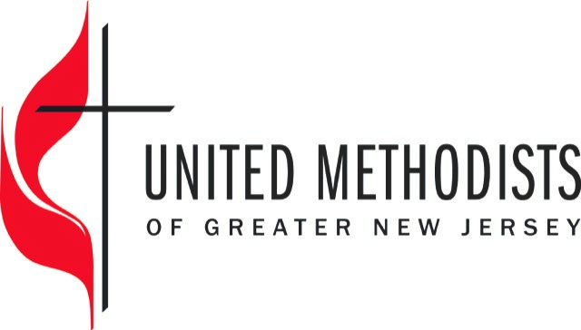
2018 Team Vital Application

Thank you for applying to Team Vital. All areas of the application, including all the signatures are required to be processed. Churches will be notified of their acceptance. Address all questions to Rev. Gina Yeske (Coordinator of Team Vital) at gyeske@gnjumc.org. Submit the following application to your Regional Administrator and copy Diana Picurro.
To input your information, click on the dark gray areas within the highlighted areas and begin typing. Please complete all gray highlighted areas. Responses must fit in the box and space provided.
Church Name/Names: |  | Church 4 digit #
Church Address: |  | District:
Senior Pastor: |  | Email:
Church Council Chair: |  | Email:
Team Vital Leader (laity): |  | Email:

To obtain your church’s statistics go to: ezra.gcfa.org using the username and password assigned to you. If you need assistance, contact your district superintendent.
 | 2015 | 2016 | 2017
Professions of Faith
Avg. Worship Attendance
Please describe, in consultation with the leadership of your church, three areas of growth required for vitality (be specific).
Please list the names of your Team Vital members and their email: As the Team Vital member, I am willing and able to commit my time and effort to the program and will do all I can to support and encourage the congregation throughout this process.
Name: |  | Email:
Name: |  | Email:
Name: |  | Email:
Name: |  | Email:
Name: |  | Email:
Name: |  | Email:
Name: |  | Email:
Name: |  | Email:
Name: |  | Email:
Name: |  | Email:
Name: |  | Email:
Name: |  | Email:

A. Agreement of the pastor

As the Pastor of United Methodist Church, I am aware of the requirements of Team Vital. I am willing and able to commit my time and effort to the program and will do all I can to support and encourage the congregation throughout this process.

Pastor

Date of Submission:

B. Agreement of the Team Vital Leader

As the Team Vital Leader of United Methodist Church, I am aware of the requirements of Team Vital. I am willing and able to commit my time and effort to the program and will do all I can to support and encourage the congregation throughout this process.

TV Leader

Date of Submission:

C. Agreement by the Local Church

The leadership of United Methodist Church has met and discussed Team Vital. We are aware of the requirements of this resource and intend to participate fully. We will commit to sending a team per the recommended guidelines to all Team Vital Ministry planning and training workshops, follow-up workshops and will take advantage of other provided resources.

We will make this program a priority for our church. Our Administrative Council/Church Board met on and have voted to commit to this program. We commit to developing a ministry plan and the training resources associated with Team Vital.

Chairperson

Date of Submission:

D. Recommendation by District Superintendent (Please note you are recommending both the pastor and the church for this program).

District Superintendent

Date of Submission

