Non-Profit Agencies that provide
Free or Low Cost Legal Assistance to Immigrants in New Jersey

American Friends Service Committee Immigrant Rights Program
89 Market Street, 6th Floor
Newark, NJ 07102
(973)643-1924

Catholic Charities
976 Broad Street
Newark, NJ 07102
(973) 733-3516

Northeast New Jersey Legal Services
152 Market Street, 6th Fl.
Paterson, NJ 07505
(973)523-2900
(VAWA/U VISA CASES ONLY – Bergen, Hudson and Passaic Counties)

Legal Services of New Jersey
P.O. Box 1357
Edison, NJ 08818
(732)572-9100
Hotline: 1-888-576-5529

Casa Esperanza
P.O. Box 2693
Plainfield, NJ 07060
(732)748-1111

CEUS
4214 Kennedy Blvd.
Union City, NJ 07087
(201)617-5366
(201)617-2466

Camden Center for Law and Social Justice
126 North Broadway
Camden, NJ 08103
(856)583-2950

Welcome House
669 Chambers Street, Ste B
Trenton, NJ 08611
(609)688-0881
M-F 10AM – 4PM (W to 6PM)
Saturdays 2-4 PM

PRAB
90 Jersey Avenue
New Brunswick, NJ 08903
(732)828-4510
Walk-in clinic hours Wed 9-6

Wind of the Spirit
120 Speedwell Ave, 2nd FL
Morristown, NJ 07960
(973)538-2035

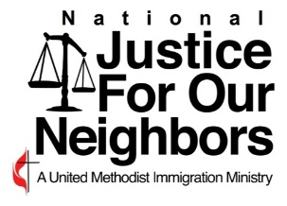
www.njfon.org

John Wesley United Methodist Church
260 Quincy Street, Brooklyn, New York 11216 • 718-783-1501
Chinese United Methodist Church
69 Madison Street, New York, New York 10002 • 212-267-6464
La Promesa Presbyterian Mission of Flushing
150-20 Barclay Avenue, Flushing, New York 11355 • 718-762-1647
Hicksville United Methodist Church
130 W Old Country Road, Hicksville, NY 11801

