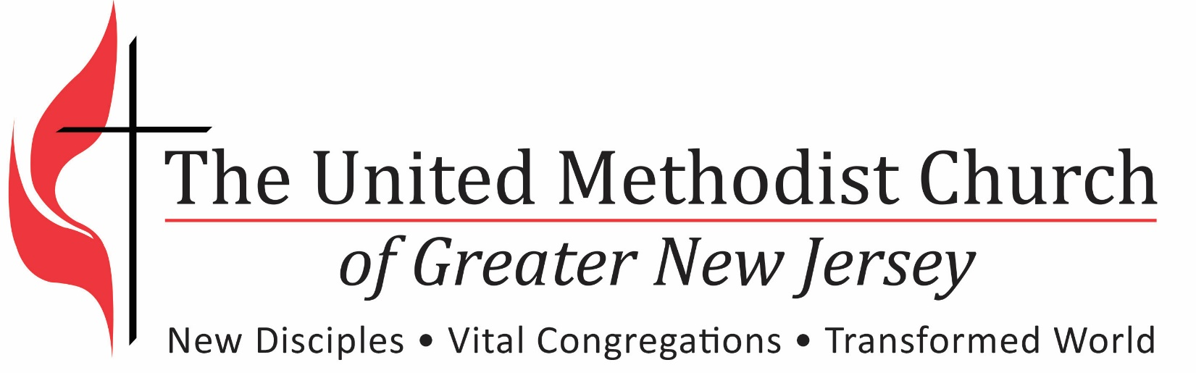

Special Services
Pastoral Transition Process
Special Services

Farewell Service:
On the current pastor’s last Sunday in a church (or other chosen date), there should be an appropriate farewell service, in which the pastor can express his/her thanks for the time shared with the congregation and the congregation can prayerfully bid their pastor farewell.

Installation Service:
On the incoming pastor’s first Sunday in a church (or other chosen date), there should be an appropriate installation and welcoming service, in which the pastor can express his/her initial vision for the congregation and the congregation can have the opportunity to express a hospitable welcome.

Re-Appointment Service:
If there is no pastoral change, on the first Sunday of a new conference year the congregation and pastor should engage in an appropriate “anniversary” – i.e., Re-Appointment celebration, in which the pastor can express his/her visions for ministry in the coming year and the congregation can welcome him/her back to the church for a new conference year.

Note: It is suggested that liturgy in the *Book of Worship and other resources may be used to provide guidance for these services.

* Farewell p. 598-599
* Installation p. 595-598
* Re-Appointment p. 595-598

