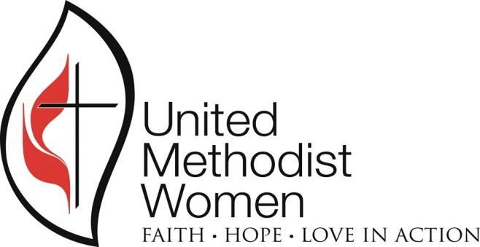

Gateway South
United Methodist Women’s
Spiritual Retreat

“Resurrection Women”

Saturday, April 29, 2017

Chews United Methodist Church
319 Black Horse Pike, Glendora, NJ

9:00AM – 12:00 noon

- Registration
- Continental Breakfast
- Spiritual Retreat
- Special Music
- Drama
- Reflection and Sharing Time

Bring a friend!
For more information contact: Naomi Walker, walkerrn@comcast.net

