**Graceful Conversations**

**in the midst of Controversies**

# Purpose

The purpose of the *Graceful Conversations* gathering is to engage in deep conversations to controversial issues in the life of the church.

The process was used in GNJ to engage in deep conversations to develop our hopes and aspirations for the future of the United Methodist Church to send to the Commission on the Way Forward put in place by the Council of Bishops, as directed by the 2016 General Conference Session.

To learn more about the Social Principles on Human Sexuality visit:

<http://www.umc.org/what-we-believe/the-nurturing-community#human-sexuality>

Graceful Conversations is a time of Christian conferencing, which per John Wesley, is a means of grace that allows us to:

1. Grow together in holiness as disciples.
2. Discern God’s voice through sharing insights with each other.
3. Speak honestly, openly and respectfully with each other.

# Process

To facilitate the conversations, Graceful Conversations uses the Circle Process. The Circle Process provides a space safe enough for the telling and hearing of stories, and going deeper in our own stories. In the image of the circle we have a visual representation of our interconnection and interdependence. In the circle, participants:

* Acknowledge God’s presence from beginning to end
* Actively listen for understanding
* Speak the truth in love
* Reject detrimental behaviors
* Make sure everyone has equal opportunity to speak and are freed to listen.

As part of the circle process a talking piece is used. The talking piece enables everyone to have a voice, including the quiet ones, often the wisest, and enables the talkers to listen.

* Speak when you are holding the talking piece.
* Listen when you are not holding the talking piece.
* Use mutual invitation -- the last speaker chooses the next person to speak rather than a leader choosing to equalize the power among all participants.
* Right to Pass - circle members may pass if they choose but still select the next speaker.

In Native American circles, a feather is often used as the talking piece as a reminder of God’s gentle presence and guidance.

To learn more about the Circle Process visit: <http://justpeaceumc.org/tools>

# Facilitators

The main role of facilitators in Graceful Conversations is to guide the conversations and keep them moving forward so that there is balance and all voices are heard and the tasks at hand for the group is accomplished. During their interactions with group members, facilitators may also ask questions for clarity, to expand possibilities and help the groups go deeper in their reflection and discernment.

As possible, facilitators should abstain from sharing their personal perspectives as this drastically changes the balance in the conversation.

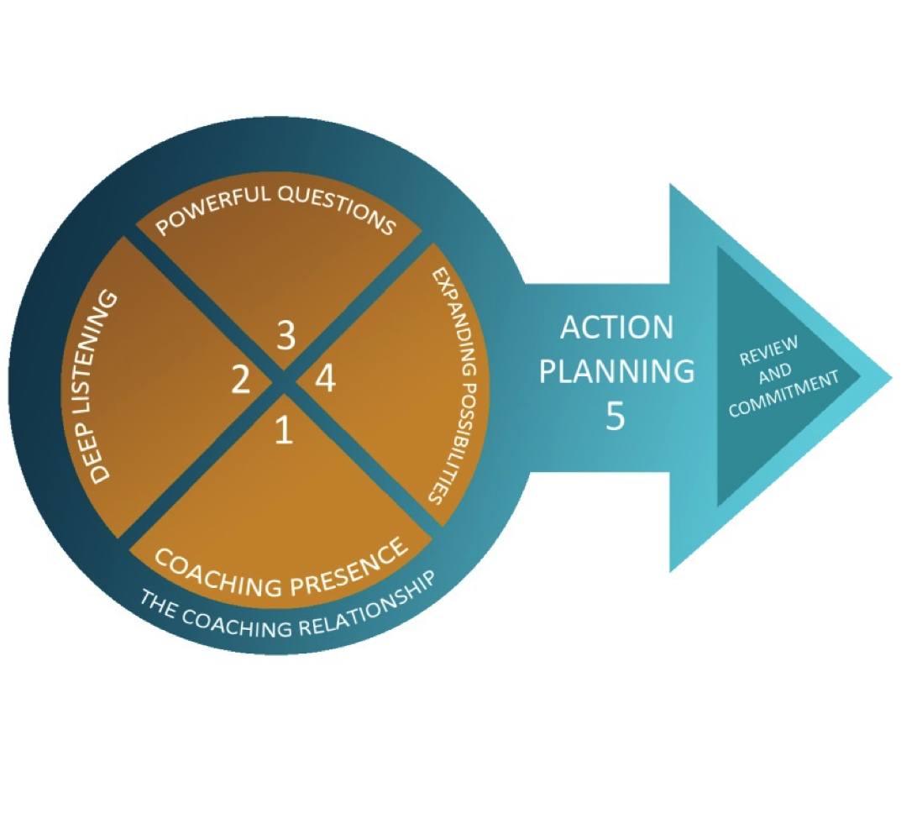

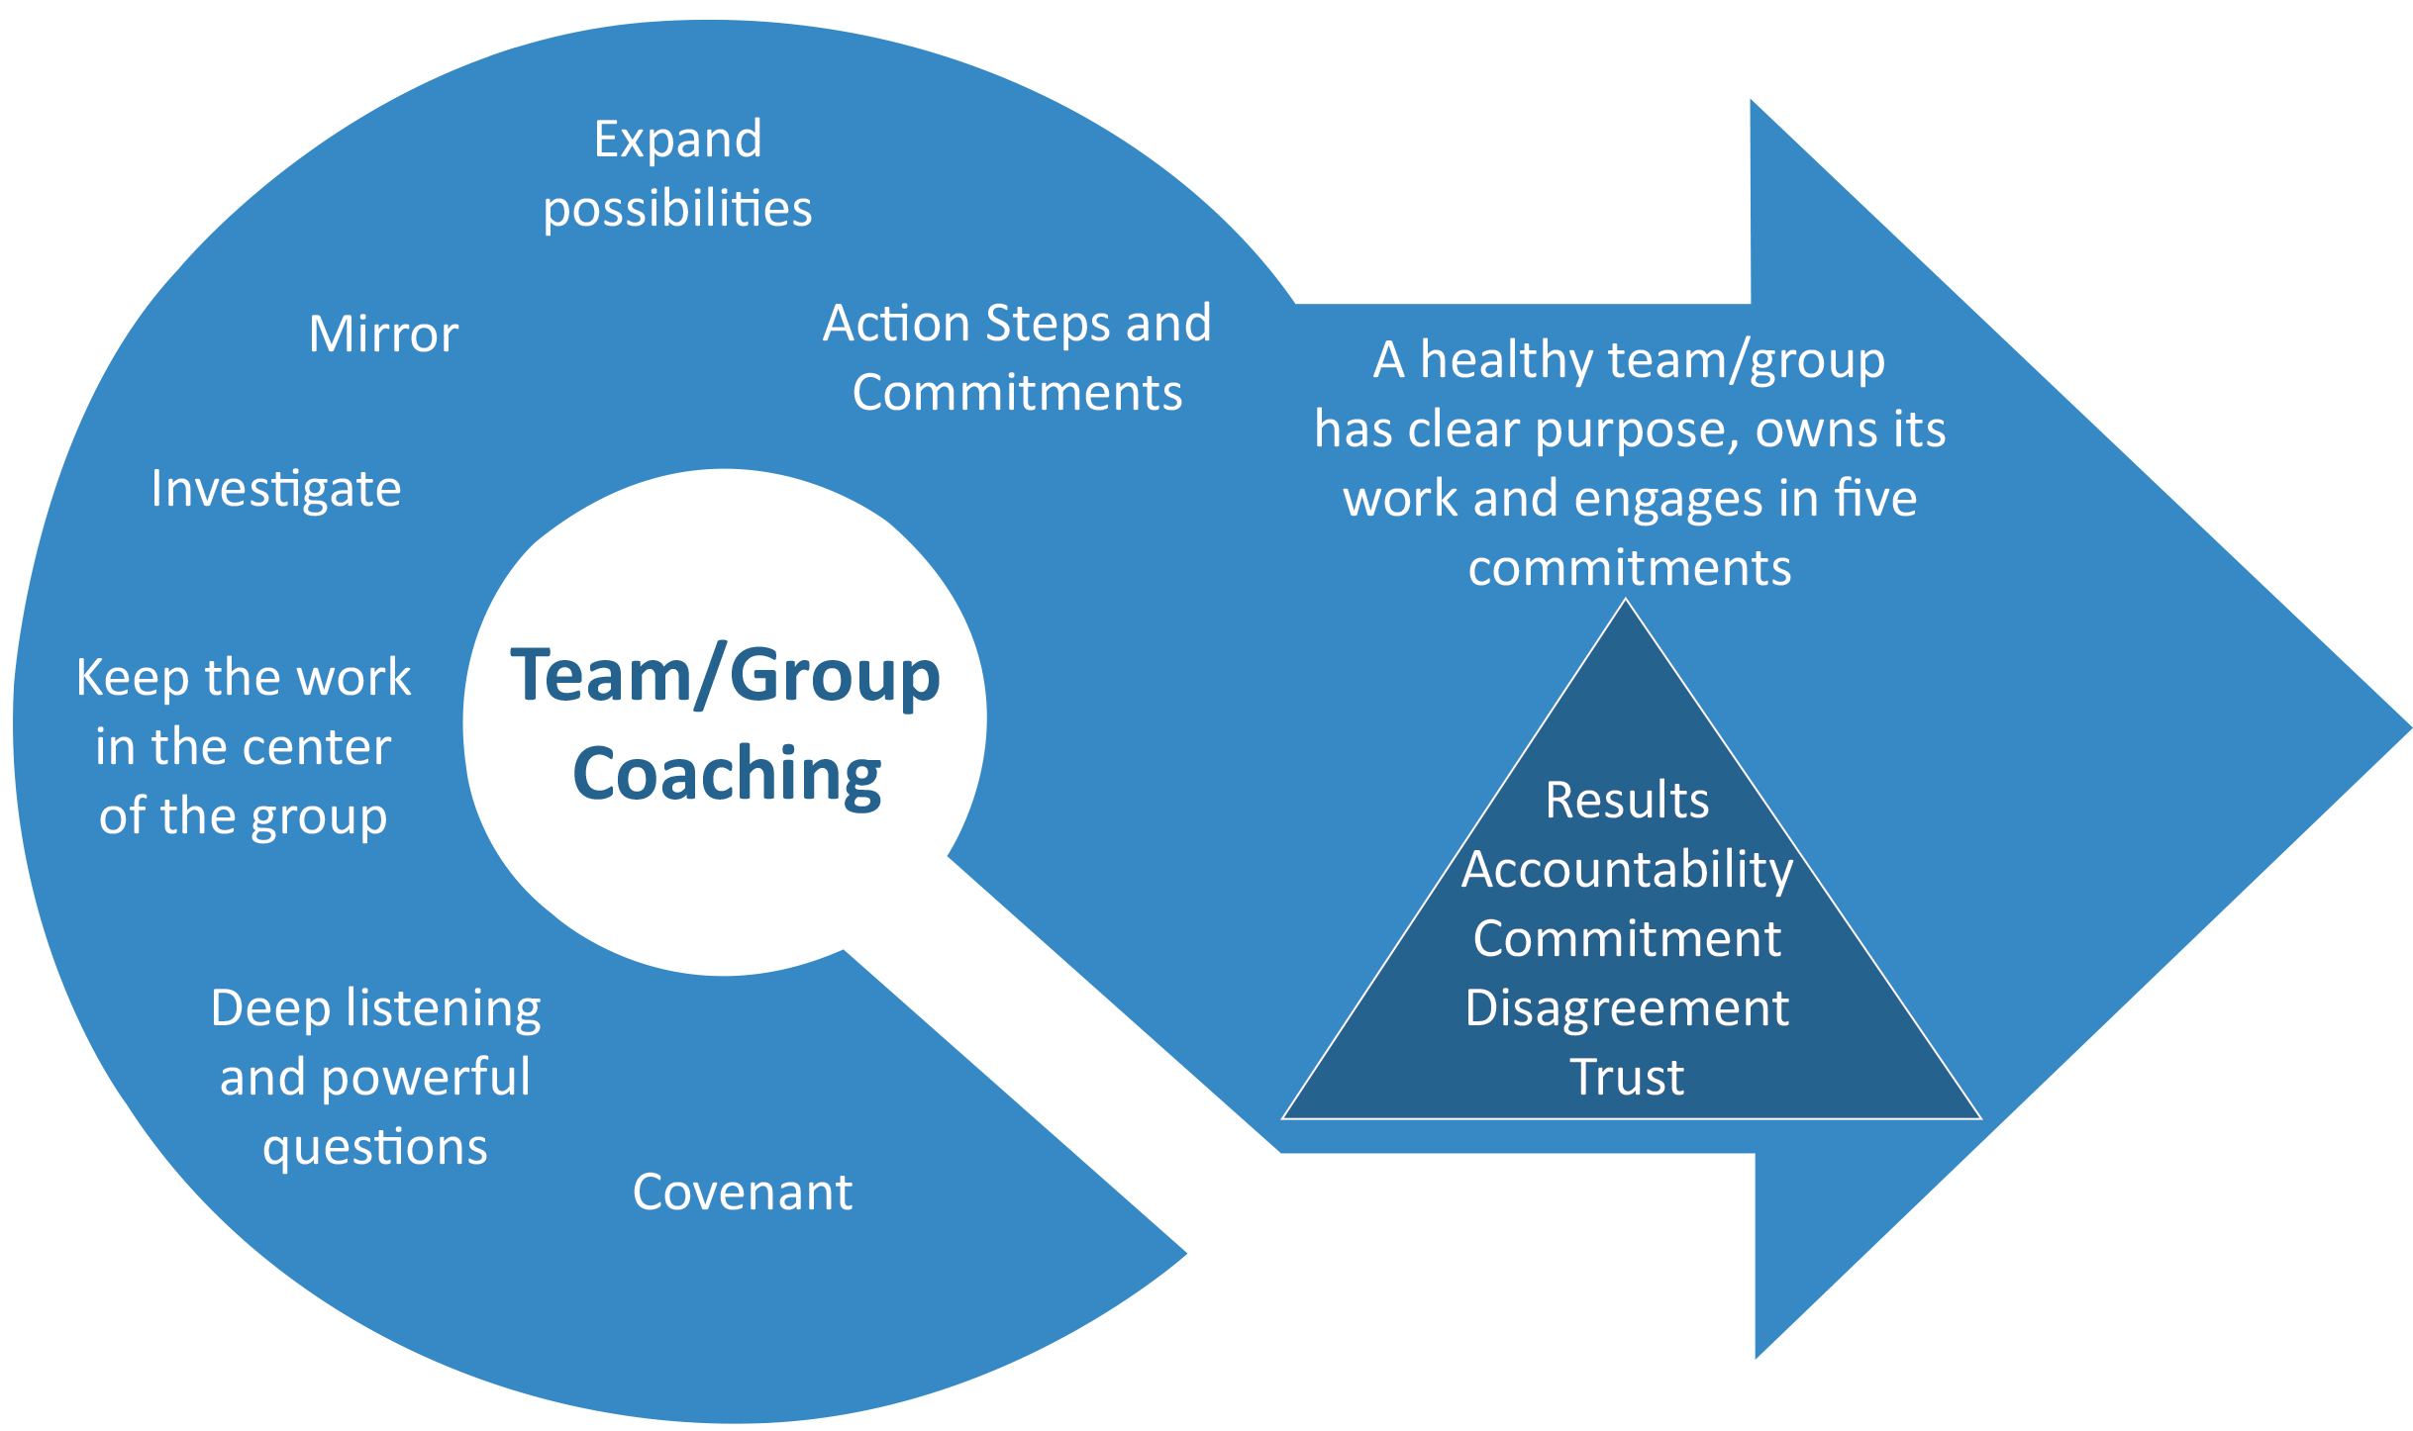

# Ground Rules and Covenant

The ground rules for Graceful Conversations are based in the three basic rules we highly value as disciples in the Wesleyan tradition:

* Do No Harm
  + Think before you speak
  + Beware of judging yourself and others unfairly
* Do Good
  + Own your thoughts and beliefs by using “I” statements.
  + Listen with a compassionate and curious heart to others especially when their experience and views are different.
  + Treasure details shared in your conversations as confidential unless told otherwise.
  + If needed, agree to disagree.
* Stay in love with God
  + Be prayerful in all and practice hospitality in our language and body language
  + Be faithful to your commitment to be a disciple of Jesus Christ.

It is important that facilitators constantly monitor the small group conversations and hold participants accountable to the shared covenant, if needed.

**Small Group Conversations**

## The Four Questions

Reflect in the following four questions:

1. In our diverse and global existence, what is the shared mission/purpose of the Church?
2. What would be a proactive way for us to live in our differences that doesn’t presume that we will resolve our differences?
3. What might be a form of unity that would empower us living together?
4. What is our witness and what can be our witness to the world in relation to our differences?

There can be up to four rotations to allow all an opportunity to share their perspectives on each question. In each rotation participants, *might* end up with a different group of people. This is done intentionally in an effort that we each hear from as many different perspectives as possible.

Facilitators must pay special attention to the suggested distribution for each rotation.

1 minute Introductions (Name and local church); select a scribe.

20 minutes Small group conversations (Circle Process)

5 minutes Capture key insight from conversations (Open ended conversation)

*What insight you heard from someone else in the group that should be shared with others?*

3 minutes Wrap up

1 minute Closing prayer

## The Seven Options

In this portion of the program, participants will spend time sharing their hopes around the seven options proposed for consideration and identify which best embodies who we are as United Methodist, here in Greater New Jersey.

The Seven Options are:

1. We continue as we are, no change to The Book of Discipline.
2. We change The Book of Discipline to allow gays and lesbians to be ordained and to permit same gender weddings.
3. The annual conference determines who is fit and ready for ordination and whether to allow clergy to perform same gender weddings.
4. Local congregations decide whether they will accept an openly gay or lesbian pastor and whether their pastor celebrates same gender weddings.
5. The church has authority on these matters by geographic region (we are organized into regions by the Africa, Asia, Europe and the United States).
6. We divide into separate denominations based on gay and lesbian ordination and same gender marriage. I
7. Other Ideas

**Guiding Question:** If we chose this option, what would you need to participate in the life of the church?

If we do not choose this option, what would you need to participate in the life of the church?

There will be 2 rotations to allow participants to reflect in 2 of the options they are most passionate or intrigued about. Small groups size will vary based in the interest of participants.

1 minute Introductions (Name and local church)

5 minutes Individual Reflection - If we chose this option, what would you need to participate in the life of the church? What represents a challenge?

25 minutes Small group conversations

**5 minutes Capture key insight from conversations**

1. Invite each participant to write their answer to the question in post it cards. Write the option number in the post it cards.
2. As they are done, invite them to post their insight in the appropriate place in the windows around the room.

1 minute Closing prayer

**SUGGESTED PROGRAM**

|  |  |
| --- | --- |
| 8:30 | Registration (with light breakfast) |
| 9:00 | Opening Worship |
| 9:30 | Creative Thinking Exercise* |
| 9:45 | Sharing of Purpose, Process, Communication, Talking Piece |
| 9:55 | Testimony #1 - Video |
| 10:00 | Small Group Table Conversations - Question 1 |
| 10:30 | Small Group Table Conversations - Question 2 |
| 11:00 | Testimony #2 -Letter (Reader, ____________________) |
| 11:05 | Small Group Table Conversations - Question 3 |
| 11:35 | Small Group Table Conversations - Question 4 |
| 12:00 | Lunch Break |
| 12:40 | Gathering Song |
| 12:45 | Explanation of afternoon Conversations |
| 12:50 | Small Group Table Conversations - 7 Options 1st Rotation |
| 1:30 | Testimony #3 – Letter (Reader, __________________) |
| 1:35 | Small Group Table Conversations - 7 Options 2nd Rotation |
| 2:15 | Testimony #4 - Audio |
| 2:20 | Thanks, draw the day together, next steps |
| 2:30 | Closing Worship / Communion |
| 3:00 | Adjourn |

Suggested exercise, recreate from this video:

<https://www.facebook.com/reggie.albert.58/posts/10154589719622639>