Lay Ministry Recognition
The primary agents of God’s mission in today’s world are the lay people or laity of the United Methodist Church, you and me. The ministry of the laity flows from a commitment of Christ’s outreaching love. Lay members of the United Methodist Church are called to be active advocates of the gospel of Jesus Christ. Every lay person is called to be in mission. The witness of the laity, their Christ-like examples of everyday living and their sharing of their own faith experiences of the gospel is the primary evangelistic ministry through which all people will come to know Christ and the way the United Methodist Church can fulfill its mission to make disciples of Christ for the transformation of the world.
We are called to serve in our homes, our work, our local community and the world. The laity role is that of a servant who models the love of Christ by example and the local church is where our labor is constant in witnessing and sharing our faith experiences of the gospel in many different ways.
The Laity Board has developed a system to honor our laity and celebrate their ministry through “Lay Ministry Recognition Awards.”
To nominate a person or group in your church for Lay Ministry Recognition to honor their creativity and innovation in transforming lives and making disciples of Jesus Christ, please complete the nomination form below. The laity will be recognized on April 22, 2017 at the Conference Mission and Resource Center, 205 Jumping Brook Road, Neptune, NJ 07753. The celebration is scheduled for 2:30 pm.
We invite you to come and celebrate with us the work of those people whose faith journey has been exemplary in our midst. Please contact Rosa Williams for questions 201-833-0352 or rosamw@optonline.net
Application must be submitted no later than March 4, 2017

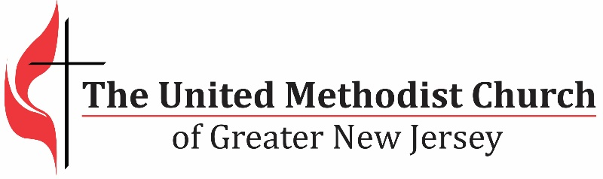
We equip spiritual leaders to make disciples and grow vital
congregations to transform the world.
Lay Ministry Recognition Nomination Form (a person or group)
Name of person or group_________________________________________________________
Name of ministry_______________________________________________________________

Nominated By_________________________________________________________________

Phone number of nominator________________________Cell phone_____________________
Have you shared nomination with nominee(s)_______________
Name of church_______________________________________________________________

Church address_______________________________________________________________

District ______________________________________________________________________

Pastor Signature________________________________________________________________

Adm. Chair Signature___________________________________________________________

Please describe in detail:

Supportive information related to this nomination:

  - How has the nominee demonstrated Christ-Like ministry toward helping people experience God’s transforming love through Jesus Christ in the Wesleyan Tradition? (provide descriptive summary)

  - How has the nominee demonstrated dedication to this ministry?

  - What is the length of service of the ministry? *
      - Community Location

      - Target population

  - What impact does this ministry have on the population being served?

  - How many members of your congregations and community are engaged in this ministry?

*Only completed Applications will be reviewed!
Application must be submitted no later than March 4, 2017

Email to: Ginny Kaiser at gkaiser@gnjumc.org

