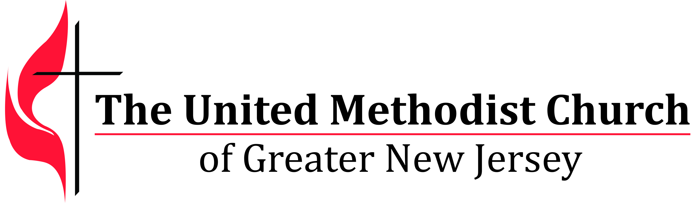
We equip spiritual leaders to make disciples and grow vital
congregations to transform the world.

Congregational Development Grant Application

OVERVIEW
Why do we exist?
We believe God’s love heals and transforms lives. God’s love is encountered in disciples of Jesus who passionately share faith, hope and justice in the community. Vital congregations form and shape passionate disciples. We equip spiritual leaders to grow vital congregations and make disciples so that God’s love heals and transforms the world.

What is our commitment?
GNJ is committed to resource and support the development of congregations and lay and clergy leadership. Equipped and vital leaders and congregations are powerful witnesses to the Gospel of Jesus Christ throughout the region.

What is a vital congregation?
Vital Congregations are inwardly transformed and missionally outbound. Vital congregations are Spirit‐ filled, forward-leaning communities of believers that grow over time, welcome all people (Galatians 3:28); make disciples of Jesus Christ through the power of the Holy Spirit (Matthew 28:18‐20); and serve like Christ through justice and mercy ministries (Micah 6:8 and Luke 4:17‐21).

What happens in vital congregations?

Life-Changing Ministries | Ministries build up the community of faith and transform lives and social conditions in the community and the world.
Fruitfulness | New disciples are being made, more disciples are participating in small groups for learning and faith formation, more disciples are engaging in worship and mission, and disciples are giving generously, particularly to mission.
Life-Full Stories | Stories are shared about changed lives, new disciples and transforming ministry.

How do vital congregations grow?
- Inspired and inviting worship
- Engaged disciples in mission and outreach
- Gifted, empowered and equipped lay leadership
- Equipped, effective, and inspired clergy leadership
- Faith-formed small group ministries, and
- Strong children and youth ministries.

What type of disciple does GNJ seek to make?
We seek disciples that will sit at the feet of Jesus and become life-long learners and followers of Jesus Christ, leaving behind safety and complacency to serve like Christ to save souls, end poverty, be graceful with those at the margins, connect with people who are different from us, and magnify God’s presence in the world. This type of discipleship is encouraged and supported through vital congregations.

What type of leaders does GNJ seek to develop?
We call leaders for their discipleship and leadership qualities. We equip them with skills.
- Leaders with a call for a heart for Jesus will develop for spiritual maturity
- Leaders with a call for passion will grow vital congregations
- Leaders with a call for vision will lead change and resolve conflict
- Leaders with a call for diversity will develop cultural competence (how to understand different cultures and community needs as well as how to interact, communicate and lead within multi-cultural contexts).
- Leaders with a call for youth will develop congregations for supporting younger leaders
- Leaders with a call for creativity and innovation will minister in particular contexts
- Leaders with a call for perseverance will develop fruitful ministry

Turnaround Spiritual Leaders:
- Assess the spiritual depth, gifts and strategies needed to grow the congregation and serve the community,
- Cast a courageous vision,
- Assist the congregation to set and achieve challenging goals,
- Inspire and equip the congregation to make new disciples,
- Grow worship attendance,
- Grow disciples’ faith through small groups,
- Engage the congregation in life changing mission, and
- Increase giving to mission and ministry.

GNJ will provide development grants to leaders and congregations that:
- Encourage innovative ministry that connects with people in the community.
- Develop lay and clergy leadership for making disciples and transforming the world.
- Maximize vital congregations.

This is a one year grant program. Consideration for funding in subsequent years will be dependent on implementation of programs, achieving goals for the grant year, timely reporting, active participation in Vital Signs Dashboard and availability of funds. This grant process does not cover requests for capital.

Grant Cycles: Equitable & Supplemental Salary: July 2017 – June 2018. All other grants: January 2017 to December 2017

A church or group of churches should only submit one grant application to cover all of their grant requests.
The application is designed to be completed electronically. The application and supporting documents must be submitted in PDF format. Only applications submitted in this format will be considered. If you need assistance in creating a pdf go to:
http://www.wikihow.com/Convert-a-Microsoft-Word-Document-to-PDF-Format.

Applications must be received by October 5, 2015. Incomplete or late applications will not be considered. Submit the following application and address all questions to Ginny Kaiser at GKaiser@gnjumc.org.
GNJUMC
2017 Grant Application – Due October 5, 2016
To input your information, click on the dark gray areas within the highlighted areas and begin typing. Please complete all gray highlighted areas. Responses must fit in the box and space provided.
Church Name: |  | Church number:
Church Address: |  | District:
Pastor: |  | Email:
Church Council Chair: |  | Email:
Staff Parish Chair: |  | Email:
Name of project: |  | Website:
Start date for program: |  | $ Total Amount being requested

1. Please indicate the type of congregational ministry this request will support. Check all that apply. | Amount Requested  Breakdown the amounts  if applying for more than one area.
Starting a new congregation or community of faith
Starting a second ministry campus (site)
Starting a new worship service
Starting or strengthening a children or youth ministry
Starting or strengthening a small group ministry
Starting or strengthening a mission ministry in the community
Expanding or strengthening other present ministry
Starting, strengthening or expanding a cooperative parish.
Leadership Development
Appointment of an additional clergy person
Equitable or Supplemental Salary
Facility support
Total $ Amount Requested

2. Describe the ministry for which you are seeking funding (what, why, who, when, where)
3. How will this project/grant encourage innovative ministry that connects with people in the community?

4. How will this project/grant develop lay and clergy leadership for making disciples and transforming the world?
5. How will this project/grant help you grow the vitality of your congregation?
6. Please list your S.M.A.R.T. goals for the grant year for the ministry program for which you are seeking funding. Make sure to specify how you will measure your success for each goal and evaluate your strategies.
7. If you have received grants for this program before, please list the goals of the ministry program you proposed before and share a brief evaluation of the outcomes.

8. How will you share your results and learnings with your congregation, and other congregations or groups involved in this ministry?

9. How is this ministry expected to be sustained in future years?

10. Use the space below to outline a budget for how you will allocate the requested funds. Include the sources of income that will support the ministry and the expense lines that will be associated with the program. Use only those lines applicable to your program (Income and Expenses amounts should be balanced).
INCOME | Amount | EXPENSES | Amount
GNJ Grant 2017  (Amount Requested) |  | Clergy Support
Local Church Contribution |  | Clergy Salary
Other Grants |  | Clergy Pension
Donations |  | Clergy Health
Fund Raising |  | Clergy Reimbursable Accounts
Scholarships |  | Ministry Program Expenses
TOTAL INCOME |  | TOTAL EXPENSES

Income and Expenses amounts should be balanced.

If applicable, please enter the funds you will be requesting to support this initiative in the subsequent years.

2018

2019

11. Please provide the following information. If this request is for several churches, add the totals for the congregations and list the combined total for each area.

Please list all the names churches included in these totals:

STATISTICAL INFORMATION

To obtain your church’s statistics go to: www.ezra.gcfa.org using the username and password assigned to you, or to the Statistical Reports and Tables section in the corresponding year’s Conference Journal. If you need assistance, contact your District Superintendent’s office.
 | 2013 |  |  | 2014 |  |  | 2015
Average weekly worship attendance ( see line #10 in your Statistical Reports as described above)
Professions of Faith (see line #2A)
Number of disciples in small groups (#19+21+22 for 2012, #19+21 for 2013 and 2014)
Number of disciples engaged in mission (#30b+31b for 2012. #27b+28 for 2013 and 2014)
Total money spent each year on mission (#40b+42-50 for 2012. #35b+ 37-45 for 2013 and 2014)
Total church operational expenses, including staff. (#65 for 2012. #60 for 2013 and 2014)
Percentage of Paid Billings
Percentage of Paid Shared Ministry

VITALITY GOALS
 |  | 2017 | 2018 |  | 2019 | 2020 |  | 2021
Average weekly worship attendance
Professions of Faith
Number of disciples in small groups
Number of disciples engaged in mission
Total money spent each year on mission
Total church operational expenses (including staff)
12. In addition to your vitality goals, are there additional goals you have for your ministry? If so, please list the top 3.
Goal 1:
Goal 2:
Goal 3:

By checking the boxes below, you confirm the following:

By checking the boxes below, you confirm the following:

Dates

Details

Amount
Church current YTD Financial Report (Income/Expenses) is attached.
Most recent Fund Balance Report is attached.
We understand that this is a one (1) year grant and that consideration for funding in subsequent years is dependent on:
- Implementing our program,
- Achieving our goals,
- Submitting requested reports on time,
- Participating in the *Vital Signs Dashboard web reporting,
- Submitting an updated application in the next grant cycle,
- and availability of funds.

*For more information on the Vital Signs Dashboard, visit online: https://www.gnjumc.org/team-vital/19554-2

Date of Submission:

Name of person submitting application:

