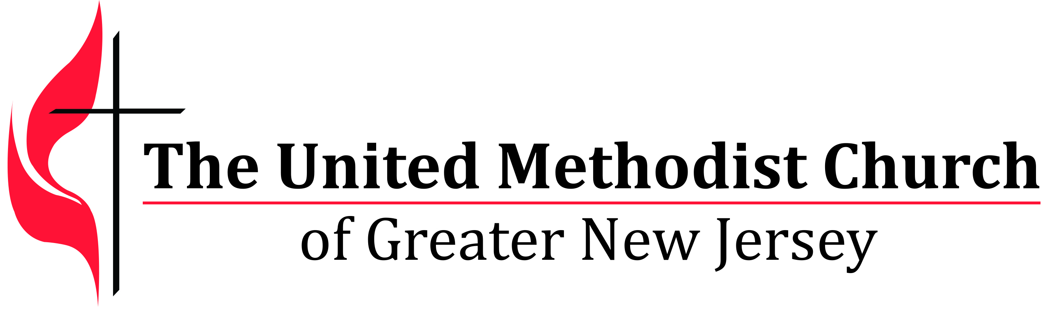

We equip spiritual leaders to make disciples and grow vital   
congregations to transform the world.

**Certified Lay Ministry Scholarship for Psychological Assessment**

**Application**

# The Laity Board celebrates and appreciates all committed disciples who are called to become Certified Lay Ministers. We are also aware of the obstacles created by the additional costs surrounding the Psychological Assessment that may hamper a disciple's journey. The Laity Board has obtained funding, allowing for a limited number of scholarships to help offset these costs.

Please complete the application, contact your District Superintendent and Chairperson of your DCOM for letters of recommendations and to express your need for this funding. Your District Superintendent will then contact Rosa Williams, Conference Lay Leader, regarding your needs. You will be advised of the amount of support available to you. May God bless you as you travel this worthwhile journey!

**Please submit all applications and letters of recommendation to Ginny Kaiser at** [Gkaiser@gnjumc.org](mailto:Gkaiser@gnjumc.org).

To input your information, click on the *dark gray* areas within the highlighted areas and begin typing. Please complete all gray highlighted areas. Responses must fit in the box and space provided.

|  |  |  |  |
| --- | --- | --- | --- |
| Name: |  | **Email:** |  |
| Address: |  | | |
| Home Phone: |  | Cell Phone: |  |
| Local Church: |  | District: |  |
| Pastor: |  | Pastor Email: |  |

|  |  |
| --- | --- |
| Date Completed: |  |
| Safe Sanctuaries Training |  |
| Sexual Ethics Training |  |
| Background Check for Laity |  |
| Recommended by DCOM to take Psychological Assessment |  |