South Seaville Camp Meeting Association
Women’s Day
Thursday, July 25, 2019

12:30 pm - Cottage Tours, Outdoor Chapel,
Prayer Tent, Lemonade Stand, Ice Cream Parlor,
Arts and Crafts, Little Acorn Shoppe

2:30 pm - From Bitter to Blessed
A Dramatic Presentation of the story of Naomi
by Rebecca Small
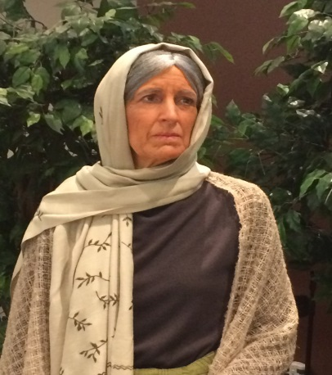
Follow this woman into despair as she confronts grief on multiple fronts. Though she feels that God has abandoned her, His providential hand is guiding and gives her a ray of hope. Emerge with her into the sweet light of God’s sovereign grace!

4:30 & 5:45 pm - Dinner
Reservations required - $10 per person
Contact Sarah Soard by July 20, 2019
856-430-9603 or ssoard@yahoo.com
Checks (payable to SSCM Auxiliary) may be mailed to
P.O. Box 524, S. Seaville, NJ 08246
South Seaville Camp Meeting Association
Women’s Auxiliary

The auxiliary began in 1928 and provided activities as fundraisers to financially support the upkeep of the campground. It later expanded its ministry to give to the needs of others. Presently, we are a community of women whose mission is to know God and to experience freedom as whole persons through Jesus Christ. We seek to develop a creative, supportive fellowship and expand concepts of mission through participation in ministries.

Our Activities Include:
Annual Women’s Tea
Annual Women’s Day
Fundraising through Yard and Bake Sales
and locally made arts and crafts to support
Ranch Hope, Urban Promise, Malachi Network, Samaritan’s Purse and local food banks
Come see our beautiful setting and experience the peace
and tranquility of the campus, cottages and prayer groves.
Visit our quaint Little Acorn Shoppe to peruse the creative
arts and crafts made by our cottagers. You will be blessed!

President – Debra Hammond
Vice President – Janice Walter
Secretary – Marilyn MacIntire
Treasurer – Barbara Holland
188 Dennisville Road, South Seaville, NJ 08246
www.southseavillecampmeeting.org

