GROWING THE CHURCH YOUNGER

GNJ Northern Regional Day of Learning
Sat, March 5, 2016
8:30am – 3:00pm
Location and Registration: Bethany Wayne UMC, Wayne, NJ
Registration Cost: $15/person or $60/church maximum

Keynote Speaker:

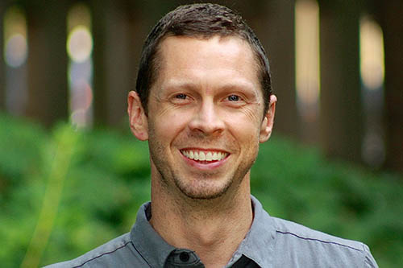
Trey Wince is the Director of New Disciples, the United Methodist Church of Greater New Jersey. Trey has 15 years of ministry experience and has served as Pastor of Kingston United Methodist Church since 2012. Prior to living in New Jersey, Trey served as College Director (serving students at Vanderbilt, Belmont and Lipscomb Universities), and Director of Young Adult Ministries at First Presbyterian Church in Nashville, Tennessee. Before serving in Nashville, he served as an international missions coordinator with Joshua Expeditions. He is a graduate of Princeton Theological Seminary and Baylor University, and holds a Certificate in Youth Ministry from the Center for Youth Ministry Training through Memphis Theological Seminary.
Workshops include those led by:
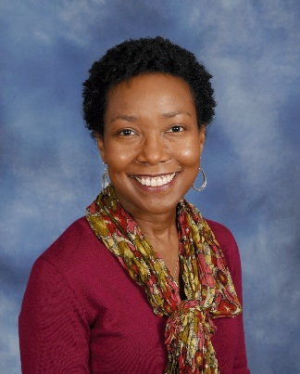
Melanie C. Gordon serves as Director of Ministry with Children at Discipleship Ministries of The United Methodist Church. She is responsible to The United Methodist Church for providing nationwide training and resourcing, while providing research and networking opportunities for leaders and teachers engaged in ministry with children. Melanie holds degrees from Clemson University and Duke Divinity School. She wrote, What Every Child Should Experience: A Guide for Teachers and Leaders in United Methodist Congregations, and blogs regularly at ministrywithchildren.com on issues that impact how children of the millennia grow in faith. Melanie loves that her ministry allows her to connect congregations and conferences with the resources that will support them as they share with children our Christian faith through developmentally appropriate and enriching experiences!

Workshop 1: What Every Child Should Experience in United Methodist Congregations What do children need to know and experience? What is developmentally appropriate? This workshop, for leaders and teachers of children in the area of faith formation, covers scripture significant for children as they develop cognitively and theologically, and what children need and understand developmentally around the beliefs and concepts of God, Worship, The Bible, Home and Family, Everyday Life, Community and Wesleyan Heritage. Practical application and helpful resources are included.

Workshop 2: God and the Digital Generation
In this world of mp3’s, social networking and mobile everything, how can the Church support parents as they spiritually form the children entrusted to our care? This workshop will equip participants with helpful, scripturally sound experiences and resources for use in the church and for parents to use at home with their young children to promote and enhance spiritual growth in a digital world.

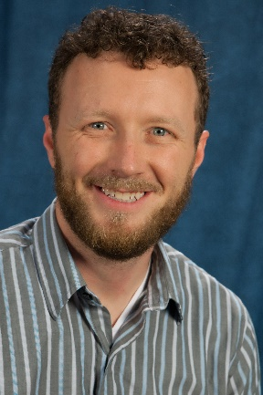
Chris Wilterdink is the Director of Program Development for Young People’s Ministries (YPM) at Discipleship Ministries. As a layperson with deep roots in youth ministry at various levels in the Rocky Mountain Conference, his ministry now encompasses resourcing and equipping world-changing disciples of Jesus Christ around the United States. He stays in touch with today’s youth ministry by volunteering as a small group leader for 11th grade boys at Christ UMC in Franklin, TN. Chris administrates the Field Guide Network, coordinates the national YOUTH event for the UMC, and manages the US-based staff team for Young People’s Ministries. Chris is a Stephen Minister and has a Masters of Science in Organizational Leadership from Regis Jesuit University. He, his wife Emily, children Graham and Luella, and sausage-shaped beagle Phurba Tashi currently reside in Franklin, Tennessee.

Workshop 1: Understanding, Reaching, & Engaging Millennial
About 1/4 of the population in the United States falls within the age boundaries of the Millennial Generation, now between the approximate ages of 12-34. The population of the United Methodist Church in the United States does not mirror that percentage. Young adults are out there, appreciating authenticity and connection. Come to explore research and hear examples of what churches around the UMC are doing to connect with Millennials. There is not one answer, so don’t come looking for a magical solution…instead come to discover what you and your church can authentically offer in connection.

Workshop 1: Covenant Discipleship Among the Young
Covenant Discipleship has significant roots in the Wesleyan Movement. It also provides a model for accountability, connection, and community that can encourage spiritual maturity and support for all ages. In 2016, Discipleship Resources will publish 3 resources related to Covenant Discipleship. These resources can function alone or together to inspire the development of Covenant Discipleship in local churches. Come to learn about the history, theology, and power of Covenant Discipleship and how that model of accountability and authenticity can become a connection point for young people in the church.

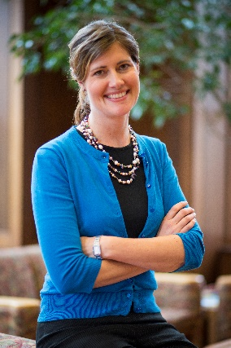
Dr. Kate Ott is author of Sex + Faith: Talking with Your Child from Birth to Adolescence, co-editor of Faith, Feminism, and Scholarship: The Next Generation, and the forthcoming Life Enhancing Settings: The Technology and Ethics of Everyday Living. She lectures and leads workshops across the country on sexuality and technology issues related to children, teens, young adults and parents. She is Assistant Professor of Christian Social Ethics at Drew University Theological School in Madison, NJ. To find out more about her work visit www.kateott.org.
Workshop 1: Body and Soul: Living our Values and Implementing Sexuality Education Plans
We are teaching about sexuality-related issues in Christian education all the time, usually without even knowing it. During this session, we will discuss ways to integrate sexuality education teachable moments throughout the faith formation of toddlers to teens. We will discuss ways that explicit, implicit and null curriculum teach sexuality related messages so as to become more intentional about communicating equitable, healthy, and positive sexuality education grounded in faith values.

Workshop 2: Sex Ed that Matters: Reaching Teens and Emerging Adults
Most teens and emerging adults are bombarded by multiple and competing sexuality messages. Faith communities are often one in a sea of voices. Responding to the changing lives of teens and emerging adults requires a transition from a behavior-based ethic and just say no approach to healthy relationship formation and values identification. This session will provide research, resources, and reflection on effective faith-based sexuality education for teens and emerging adults.

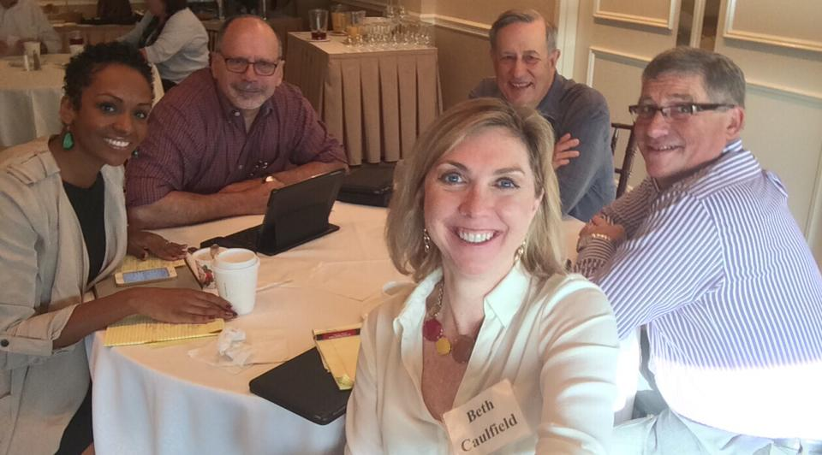
GNJ Northern Region Leadership Team

Workshop: Not Lost in Translation: Connecting New Generations to Risk-Taking Mission
We’ve heard it all before: the majority of young adults are unapologetically uninterested in church. Despite this reality, creative and risk-taking mission constructs a bridge that connects the church to new generations. Following a February 2016 Mission exploration trip to Cuba, join GNJ’s Director of Mission Nicole Caldwell-Gross, Director of Small Groups Beth Caulfield, District Superintendents Steve Bechtold and Manuel Sardinas as we share how meaningful mission experiences can jumpstart your mission movement on the road to intergenerational vitality.

