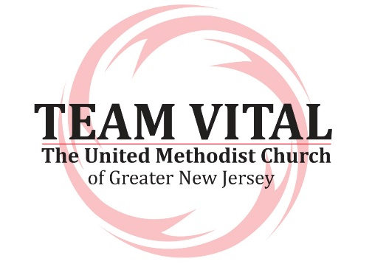

**Team Vital Leadership Roles**

**Facilitators** lead the process for a group of five to eight local Team Vital teams.

Facilitators:

* work in tandem with other facilitators through the entire 18-24 months process (orientation session through 18 month follow up).
* schedule and lead an orientation session for team leaders and pastors approximately four weeks prior to the first session.
* lead the two group sessions.
* provide monthly follow-up check-ins with teams for 18 months. Check ins consist of 15 to 20 minute calls with pastor and team leaders.
* plan and lead follow up sessions for teams six months after the initial group sessions are completed.

**Host church coordinators** are members of the host church. They work with a logistics coordinator to provide meals and other needs provided by the host church. It is recommended that the host church not be a congregation participating in the Team Vital process OR that Team Vital participants not provide the host services so they are not distracted from the work of the session.

Host church coordinators:

* plan and provide meals, including preparation and clean-up.
* recruit local church volunteers to assist with meals, etc.
* set up projectors and screens as needed.
* provide for set-up and clean-up of areas needed for sessions.
* arrange for building needs (un-locking doors, table set-up, heat, etc.).

**Team leaders** are lay people designated from each local Team Vital who **c**onvene and lead the local team through the planning and follow-up process. The qualities and qualifications for team leaders can be found in the overview booklet.

Team leaders:

* attend the orientation session three to four weeks prior to the first session.
* schedule, in consultation with the pastor, the pre-work session on vision and congregational and community assessments.
* communicate to the team the schedule for all sessions.
* work with the team to develop an action plan that will be presented to the church council.
* represent the team on the church council/administrative board.
* plan with the team for the presentation of the action plan to the church council and the congregation at large.
* participate in monthly conference call with the facilitator and pastor.
* schedules the team to attend the six month follow-up session.
* works with the pastor, church council, and other leaders to keep the plan on track and assess needed adjustments during the process.

**Pastors** are key advocates and participants in the Team Vital process.

Pastors:

* work with the church council to recruit and invite people to be a part of Team Vital.
* assess with church leadership and invite effective team leaders.
* work to support the team leader throughout the Team Vital process.
* identify leadership needs of the action plan for appropriate nominations.
* help to identify needed resourcing for fulfilling the action plan.
* participate in the orientation session and monthly follow-up calls with facilitators.
* casts the vision through preaching, teaching, administrative functions, and pastoral work.
* works with a coach to assist in the process of moving the church towards fulfilling the vision.