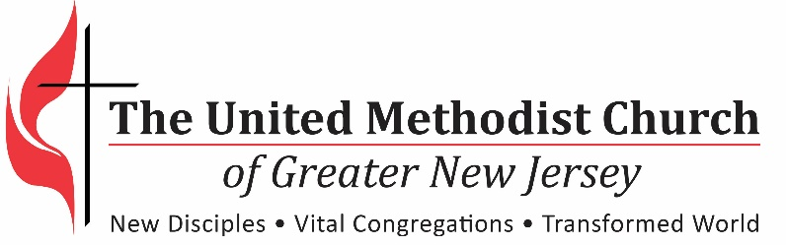

Position Application

Thank you for your interest in working with the United Methodist Church of Greater New Jersey. We provide leadership and administration for more than 560 United Methodist congregations in New Jersey, New York and Pennsylvania.

We are a dynamic and growing organization that represents The United Methodist Church and employees are expected to share in our values of service to God and others, welcome all people and seek justice and mercy in the world. We are looking for dedicated individuals who take initiative, value excellence, think creatively, are innovative and are passionate. Please complete the following questions and submit with your resume as an attachment.

Position you are applying for:

Name:

Address:

Email:

Phone:

___ Are you legally entitled to work in the United States (verification will be required)?

Work history for your last three positons:
Company name:
Address:
Position title and primary responsibility:
Reason for leaving:
Supervisor, phone number and email:
Dates of employment:

Company name:
Address:
Position title and primary responsibility:
Reason for leaving:
Supervisor, phone number and email:
Dates of employment:

Company name:
Address:
Position title and primary responsibility:
Reason for leaving:
Supervisor, phone number and email:
Dates of employment:

Education:

School/Program:
Field of Study:
Degree and Graduation Date:

School/Program:
Field of Study:
Degree and Graduation Date

School/Program:
Field of Study:
Degree and Graduation Date

Please list other qualifications such as special skills, abilities or service that should be considered:

What additional skills do you have for this position?

Please list your software and business application skills and experience:

Please list relevant professional licenses, certifications, memberships or affiliations:

What are your three greatest career accomplishments?

What leads to your success (helps you to succeed in any activity you do) and what detracts from your being successful?

When you communicate with others, what are the one or two key things you do to motivate people?

Why are you interested in this position?

Why do you want to work for The United Methodist Church?

Please submit this application along with resume and cover letter by email to Jay Kim, Manager of Administrative Services jkim@gnjumc.org with the title of the position you are applying for in the subject line. Candidates will only be considered if all materials are submitted together.

