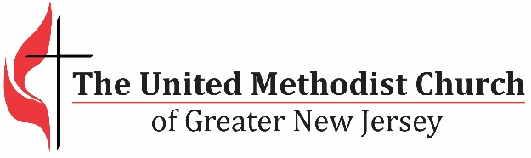

*We equip transformational leaders to make disciples*

*and grow vital congregations to transform the world.*

**2016 Agency Goals Worksheet**

**Why is it important for GNJ agencies to set goals each year?**

Agencies play an important role in helping move forward our mission and strategic plan. Setting goals each year brings focus and provides clarity on what to work and plan for. As goals are set and shared with other agencies, more clarity and alignment is achieved, new opportunities for collaboration arise and we make better use of the resources available to fulfill our mission.

**Vision**

We see a church like Jesus Christ – radical spirit and humble, teaching and healing, soul saving and soul tending, leader and servant, unbound and outbound. We also see a Wesleyan Church – personal holiness and social holiness, connectional and risk taking, thoughtful and inspirational, small groups and large vision, welcoming all and respect for diversity of thought.

**Mission**

Equip transformational leaders to make disciples and grow vital congregations to transform the world.

**2018 Goal**

Increase the number of highly vital congregations from 14% to 41%

**GNJ Strategy**

Call, equip, send and support transformational leaders and resource congregations to assess their ministry and establish a path to vitality.

**2018 Objectives**

1. Increase the percentage of churches growing in worship attendance from 33% to 51%
2. Start 90 new faith communities
3. Decrease the number of worshipers it takes to make a new profession of faith from 17 to 15
4. Increase the percentage of worshipers in small groups from 43% to 75%
5. Increase the number of young adults in small groups from 2820 to 3200
6. Increase our racial ethnic worshipers from 20% to 25%
7. Increase the percentage of worshipers engaged in mission from 8% to 40%
8. Raise $12 million through a mission campaign

**Agency Ministry Alignment**

Agency ministry will align with the strategic plan and carry out the following responsibilities:

* Research new strategies and technologies
* Explore and recommend workshops to develop transformational leaders, grow vitality and engage the community
* Write blogs and provide information for the GNJ website and other communication platforms to inspire, resource and focus leaders and congregations
* Fulfill Disciplinary mandates related to the agency

**GNJ Decision Making Guidelines**

We will only invest our financial and human resources in decisions that:

1. Encourage innovative (creative and risk taking) ministry that connects with people in the community
2. Develop lay and clergy leadership for making disciples and transforming the world
3. Maximize vital congregations

2016 Agency Goals Worksheet – **Due December 15, 2015**

To input your information, click on the *dark gray* areas within the highlighted areas and begin typing. Please complete all gray highlighted areas. Responses must fit in the box and space provided. The term “agency” includes all committees, councils, boards and commissions.

|  |  |  |  |
| --- | --- | --- | --- |
| Agency Name: |  | | |
| Chair Name: |  | **Email:** |  |
| **List the names of the agency members that collaborated in setting goals for the year 2016** | | | |
|  | | | |

|  |
| --- |
| **In one or two sentences, describe how the work of your agency aligns with GNJ mission and strategic plan** |
|  |
| **List two measurable goals for your agency for the year 2016. Make sure you specify how the goals support strategic plan and how you will evaluate the progress/success for each goal.** |
| **Goal 1:** |
| **Goal 2:** |

This worksheet must be submitted electronically in Microsoft Word format to Ginny Kaiser at [GKaiser@gnjumc.org](mailto:GKaiser@gnjumc.org) by **December 15, 2015.**