2015 Regional Day with
Bishop John Schol

Trust within the Church
In a recent study, trust was found to be the number one issue to address within The United Methodist Church. Without trust we use behaviors that do not build up the body of Christ.
- What behaviors have trust as a starting point?
- What behaviors do not have trust as a starting point?
- What will we do to grow trust?

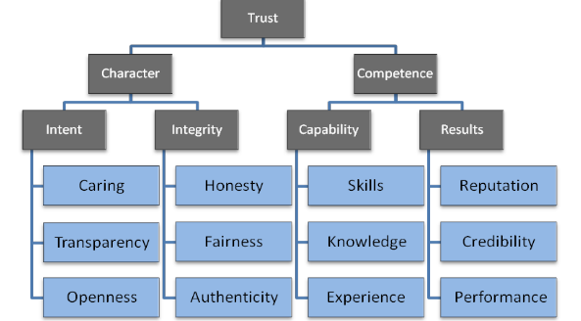

Appointments and Pastoral Expectation
Appointment process
Pastoral Expectations - The basic expectations for every pastor are:
- Connect and relate well with church leadership and membership and community residents.
- Develop leaders within the congregation.
- Lead the congregation to deeper faith and service in the world.
- Increase vitality through inspiring worship and messages, attracting and making new disciples, and engaging disciples in small groups, community hands-on mission and generous giving.
- Raise sufficient funds for their salary and benefits, shared ministries, ongoing congregational ministry, and community and world mission.
New evaluation process
Human Sexuality and Difference
How will we lead forward in the midst of difference?
- We believe you are a theologian and we will refer people back to their pastor
- We trust that you will lead your congregations to do good theological work
- We will not try to change one another but understand each other and honor each others calling
- We will live with difference
What do you need from conference leadership to help you be a local theologian, do good theological work, and live with and honor difference?
Maintenance 2 Mission
- Why the maintenance 2 mission proposal
- Our present mission is not sustainable and doing the same thing will only achieve the same results. We want to be a strong vital conference that is making a difference in people’s lives, communities and the world.
- What is the new role of superintending and what does it mean for you, the church, and the world
  - Focus superintending on growing leadership and congregations, connecting with new edge leaders, and starting new faith communities
  - Shared services
  - Supplement superintending with Circuit Elders
  - Use consultant guides to work with congregations in conflict, clergy in need of improvement plans, and to assist congregations with evaluations

