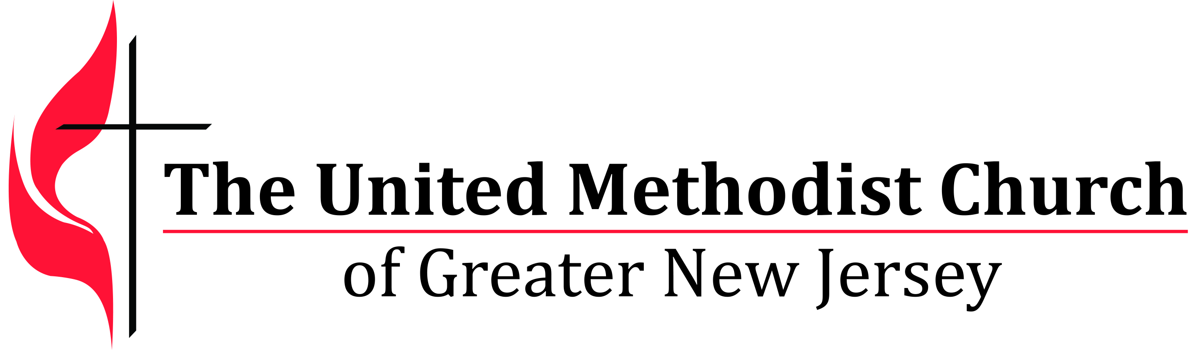
We equip spiritual leaders to make disciples and grow vital
congregations to transform the world.

Laity Leadership Academy Seed Grant

OVERVIEW
Why do we exist?
We believe God’s love heals and transforms lives. God’s love is encountered in disciples of Jesus who passionately share faith, hope and justice in the community. Vital congregations form and shape passionate disciples. We equip spiritual leaders to grow vital congregations and make disciples so that God’s love heals and transforms the world.

What is our commitment?
GNJ is committed to resource and support the development of congregations and lay and clergy leadership. Equipped and vital leaders and congregations are powerful witnesses to the Gospel of Jesus Christ throughout the region.

What is a vital congregation?
Vital Congregations are inwardly transformed and missionally outbound. Vital congregations are Spirit‐ filled, forward-leaning communities of believers that grow over time, welcome all people (Galatians 3:28); make disciples of Jesus Christ through the power of the Holy Spirit (Matthew 28:18‐20); and serve like Christ through justice and mercy ministries (Micah 6:8 and Luke 4:17‐21).

What happens in vital congregations?

Life-Changing Ministries | Ministries build up the community of faith and transform lives and social conditions in the community and the world.
Fruitfulness | New disciples are being made, more disciples are participating in small groups for learning and faith formation, more disciples are engaging in worship and mission, and disciples are giving generously, particularly to mission.
Life-Full Stories | Stories are shared about changed lives, new disciples and transforming ministry.

How do vital congregations grow?
- Inspired and inviting worship
- Engaged disciples in mission and outreach
- Gifted, empowered and equipped lay leadership
- Equipped, effective, and inspired clergy leadership
- Faith-formed small group ministries, and
- Strong children and youth ministries.

What type of disciple does GNJ seek to make?
We seek disciples that will sit at the feet of Jesus and become life-long learners and followers of Jesus Christ, leaving behind safety and complacency to serve like Christ to save souls, end poverty, be graceful with those at the margins, connect with people who are different from us, and magnify God’s presence in the world. This type of discipleship is encouraged and supported through vital congregations.

What type of leaders does GNJ seek to develop?
We call leaders for their discipleship and leadership qualities. We equip them with skills.
- Leaders with a call for a heart for Jesus will develop for spiritual maturity
- Leaders with a call for passion will grow vital congregations
- Leaders with a call for vision will lead change and resolve conflict
- Leaders with a call for diversity will develop cultural competence (how to understand different cultures and community needs as well as how to interact, communicate and lead within multi-cultural contexts).
- Leaders with a call for youth will develop congregations for supporting younger leaders
- Leaders with a call for creativity and innovation will minister in particular contexts
- Leaders with a call for perseverance will develop fruitful ministry

Turnaround Spiritual Leaders:
- Assess the spiritual depth, gifts and strategies needed to grow the congregation and serve the community,
- Cast a courageous vision,
- Assist the congregation to set and achieve challenging goals,
- Inspire and equip the congregation to make new disciples,
- Grow worship attendance,
- Grow disciples’ faith through small groups,
- Engage the congregation in life changing mission, and
- Increase giving to mission and ministry.

GNJ will provide development grants to leaders and congregations that:
- Encourage innovative ministry that connects with people in the community.
- Develop lay and clergy leadership for making disciples and transforming the world.
- Maximize vital congregations.

This seed grant program, is offered to teams of lay leaders who have attended the Laity Leadership Academy and completed an Action Plan to develop a project/initiative in their local church around the areas of worship, small groups, making new disciples and social media communication ministries. Grants amounts will not exceed $500 and will be allocated based on demonstrated willingness and readiness to grow vital congregations and develop lay leadership. This is a one-year/ one-time grant program.

A church team should only submit one grant application. The application is designed to be completed electronically. The application and supporting documents must be submitted in PDF format. Only applications submitted in this format will be considered. If you need assistance in creating a pdf go to:
http://www.wikihow.com/Convert-a-Microsoft-Word-Document-to-PDF-Format.

Applications must be received by November 30, 2017. Incomplete or late applications will not be considered. Submit the following application and address all questions to Ginny Kaiser at dpicurro@gnjumc.org.
GNJUMC
2017 Laity Leadership Academy Grant Application – Due November 30, 2017
To input your information, click on the dark gray areas within the highlighted areas and begin typing. Please complete all gray highlighted areas. Responses must fit in the box and space provided.
Church Name: |  | Church number:
Church Address: |  | District:
Pastor: |  | Email:
Church Council Chair: |  | Email:
Project Contact: |  | Email:

Name of Project: |  |  | Laity Academy Track (Only check one box) | Worship (both tracks)  Small Groups Evangelism  Older Adults
Start date for project: |  |  | Planned Evaluation Dates:
List the names of the members of the project’s Planning Team.
(Ex. Pastor Smith, John Carl (Communications Coordinator), Nancy Caterson (Young Adult volunteer)
Please describe your Project (what, why, who, when, where)
(Ex. FUMC @ Facebook. Create a Facebook Page for our church. With more and more people connecting on Facebook, this will be an effective way for our church to offer connection points and stay in touch with our congregation and the community, promote church events, etc. Our goal is for the page to be fully functional by Easter 2017.
List up to three measurable goals for the project.
(Ex. Goal 1: Reach 250 “likes” by Easter 2017 | Goal 2: Engage 50 people a week through different connection points (inspirational messages, questionnaires, photos, event promotions, etc. by 6/1/2017
Goal 1:
Goal 2:
Goal 3:
List the action steps your team will take to implement the project. Please specify who will be responsible for each step and by when each step is expected to be completed.
Action Steps  Ex. 1. Recruit Social Media team.  2. Research social media usage using MissionInsite and survey. |  | Responsibility  1) Pastor Smith, John Carl  2) John Carl, Nancy Caterson |  |  | Due Date  1. 12/01/15  2. 1/5/16

How will you evaluate the progress/success of the program?
Ex. 1) Number of page “likes” and people engaged using Facebook Page Analytics; 2) Questionnaires in Facebook and using Survey Monkey; 3) Testimonies from church members and page users.

How will you share your results and learnings with your congregation, and other groups involved in this ministry?

(Ex. Evaluation reports, testimonies posted in Facebook, web page and church newsletter).

Use the space below to outline a budget for your project. Income and Expenses amounts should be balanced.
INCOME | Amount | EXPENSES | Amount

GNJ See Grant 2017

(Amount Requested)

Local Church Contribution

Other Grants

Donations

Fund Raising

Scholarships
TOTAL INCOME |  | TOTAL EXPENSES

By checking the boxes below, you confirm the following:

By checking the boxes below, you confirm the following:

Dates

Details

Amount
This application was reviewed and approved by the pastor and church council.
Grants will be awarded based on demonstrated willingness and readiness to grow laity leadership and the vitality of your congregation.

Date of Submission:

Name of person submitting application:

The application and supporting documents must be submitted in PDF format. Only applications submitted in this format will be considered. If you need assistance in creating a pdf go to:
http://www.wikihow.com/Convert-a-Microsoft-Word-Document-to-PDF-Format.

Applications must be received by November 30, 2017. Incomplete or late applications will not be considered. Submit the following application and address all questions to Ginny Kaiser at dpicurro@gnjumc.org.

