*Therefore go and make disciples of all nations, baptizing   
them in the name of the Father and of the Son and of the Holy Spirit*

Matthew 28:19

**Name of Church:** **Pastor:**  **Team Vital Leader:**

|  |
| --- |
| **Our Community** |
| **Our Church** |
| **Our Vision** |



**Worship Goals**

|  |  |  |  |  |  |
| --- | --- | --- | --- | --- | --- |
| **Outcome** | **Responsibility** | **Action Steps** | **Needed Resources** | **Deadline** | **Assessment Plan** |
| Children welcomed, valued and celebrated in worship and growing in their faith. Enhanced worship experience for people of all ages. | 1. Pastor John,  2. Carole (Christian Ed),  3) Judith (Children Coordinator) | Include a “children’s moment” in the 8:30a worship service | Children sermons ideas or curriculums; volunteer teachers, schedule for volunteers, budget for curriculums and materials, advertising in church and community newsletter, etc. | 09/05/2015 | Measure the # of children participating in worship. Focus group conversations with children/parents. Evaluation survey every 3 months during the first year. |
|  |  |  |  |  |  |
|  |  |  |  |  |  |
|  |  |  |  |  |  |
|  |  |  |  |  |  |
|  |  |  |  |  |  |
|  |  |  |  |  |  |
|  |  |  |  |  |  |
|  |  |  |  |  |  |
|  |  |  |  |  |  |

**New Disciples Goals**

|  |  |  |  |  |  |
| --- | --- | --- | --- | --- | --- |
| **Outcome** | **Responsibility** | **Action Steps** | **Needed Resources** | **Deadline** | **Assessment Plan** |
|  |  |  |  |  |  |
|  |  |  |  |  |  |
|  |  |  |  |  |  |
|  |  |  |  |  |  |
|  |  |  |  |  |  |
|  |  |  |  |  |  |
|  |  |  |  |  |  |
|  |  |  |  |  |  |
|  |  |  |  |  |  |
|  |  |  |  |  |  |
|  |  |  |  |  |  |
|  |  |  |  |  |  |
|  |  |  |  |  |  |

**Mission Goals**

|  |  |  |  |  |  |
| --- | --- | --- | --- | --- | --- |
| **Outcome** | **Responsibility** | **Action Steps** | **Needed Resources** | **Deadline** | **Assessment Plan** |
|  |  |  |  |  |  |
|  |  |  |  |  |  |
|  |  |  |  |  |  |
|  |  |  |  |  |  |
|  |  |  |  |  |  |
|  |  |  |  |  |  |
|  |  |  |  |  |  |
|  |  |  |  |  |  |
|  |  |  |  |  |  |
|  |  |  |  |  |  |
|  |  |  |  |  |  |
|  |  |  |  |  |  |
|  |  |  |  |  |  |

**Small Groups Goals**

|  |  |  |  |  |  |
| --- | --- | --- | --- | --- | --- |
| **Outcome** | **Responsibility** | **Action Steps** | **Needed Resources** | **Deadline** | **Assessment Plan** |
|  |  |  |  |  |  |
|  |  |  |  |  |  |
|  |  |  |  |  |  |
|  |  |  |  |  |  |
|  |  |  |  |  |  |
|  |  |  |  |  |  |
|  |  |  |  |  |  |
|  |  |  |  |  |  |
|  |  |  |  |  |  |
|  |  |  |  |  |  |
|  |  |  |  |  |  |
|  |  |  |  |  |  |
|  |  |  |  |  |  |

**Giving Goals**

|  |  |  |  |  |  |
| --- | --- | --- | --- | --- | --- |
| **Outcome** | **Responsibility** | **Action Steps** | **Needed Resources** | **Deadline** | **Assessment Plan** |
|  |  |  |  |  |  |
|  |  |  |  |  |  |
|  |  |  |  |  |  |
|  |  |  |  |  |  |
|  |  |  |  |  |  |
|  |  |  |  |  |  |
|  |  |  |  |  |  |
|  |  |  |  |  |  |
|  |  |  |  |  |  |
|  |  |  |  |  |  |
|  |  |  |  |  |  |
|  |  |  |  |  |  |
|  |  |  |  |  |  |

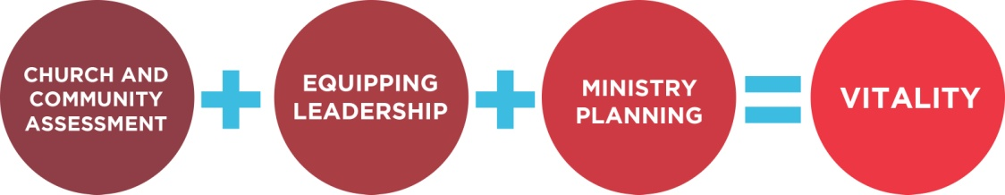

|  |  |  |
| --- | --- | --- |
| **Leadership**  **Buy-in**  **Strategy** |  | |
| **Action Plan Communications Strategy** | |  |
| **Overall**  **Action Plan**  **Assessment**  **Strategy** |  | |