Mt. Zion Wesley United Methodist Church
Come share IN our

“POWER HOUR OF PRAYER”

December 9, 2017 @ 11 a.m. – Noon

Celebrating the birth of Jesus Christ and his blessings for 2017

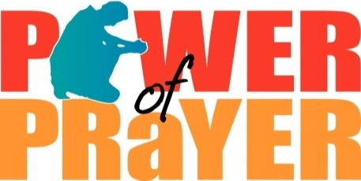
1470 Glassboro Road
Deptford Township, NJ 08096
(856) 468-4692

Sponsored By: Team Vital Committee

Rev. Dr. Stafford j. miller, pastor
Sister Rebecca Tribbett, Committee Chairperson

