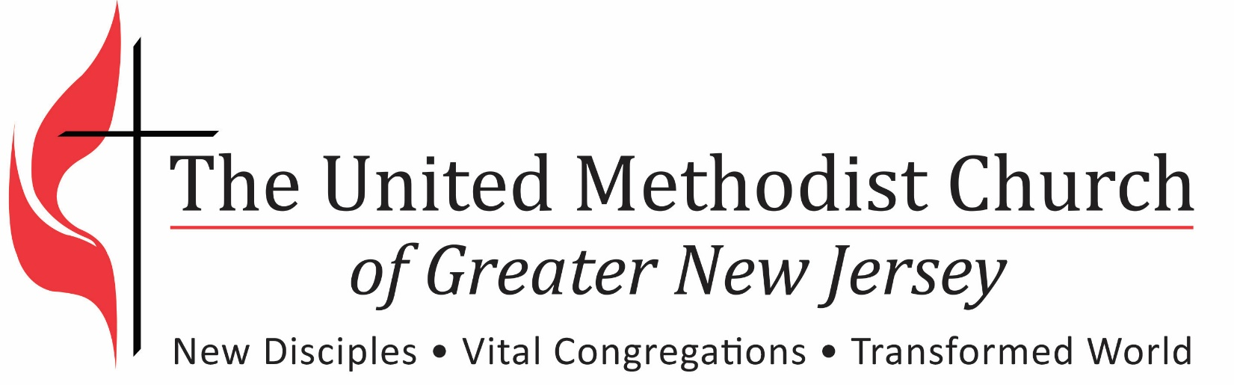

Some Interesting “Conversation Topics” For Church Groups
Pastoral Transition Process
Some Interesting “Conversation Topics” For Church Groups
(Some Things Your Church & All New Pastors Will Want To Discover)

When any group gets together they share ideas, information, insights and opinions. Sometimes we miss opportunities to intentionally direct our conversations toward topics that could produce helpful data for our church. Here are some topics that most people find invigorating. Often the results of these discussions are enlightening. Surely every new pastor wants to know the answers to these questions. The list might be helpful to your church.

- What is the context of our ministry?
  - What is happening in the congregation?
  - What is happening in the community?
  - What are the trends for both?
  - Who is our constituency? (Those for whom we are responsible)
- Geographic, economics, education, ethnicity, etc.?
- Areas of concern, special populations, etc.?
- How do our demographics compare with the community?

- Identity
  - Who are we as a congregation?
- Religious perspective?
- What is our history?
  - Do we have a vision for our future?
  - What has changed about us?
  - Where are we headed? Where do we hope to head?
  - What are our leadership needs?
  - What needs to be done? What changes must we make?

- Program / Ministry
  - What is our understanding of worship?
  - What are our ministry priorities, with benchmarks and timelines?
  - Where are we addressing ministry needs? Where are we not addressing them?
  - Do we focus on member needs of or those in the wider community?
  - How do we understand ourselves as a United Methodist congregation?

- Process
  - How do we make decisions?
  - What are our communication networks?
  - What are our leadership styles?
  - What are our norms for behavior?
  - What are the informal networks of power?

- Helpful Information
  - What do the census studies say about our ministry opportunities?
  - Church data – who really “knows” and how is information shared?
  - What are the programs of our church and who makes it happen?
  - What are Our Stories?
  - Interviews with community leaders – Who do they say that we are?
  - Do we have an inventory of present and potential leadership (a talent bank)?

