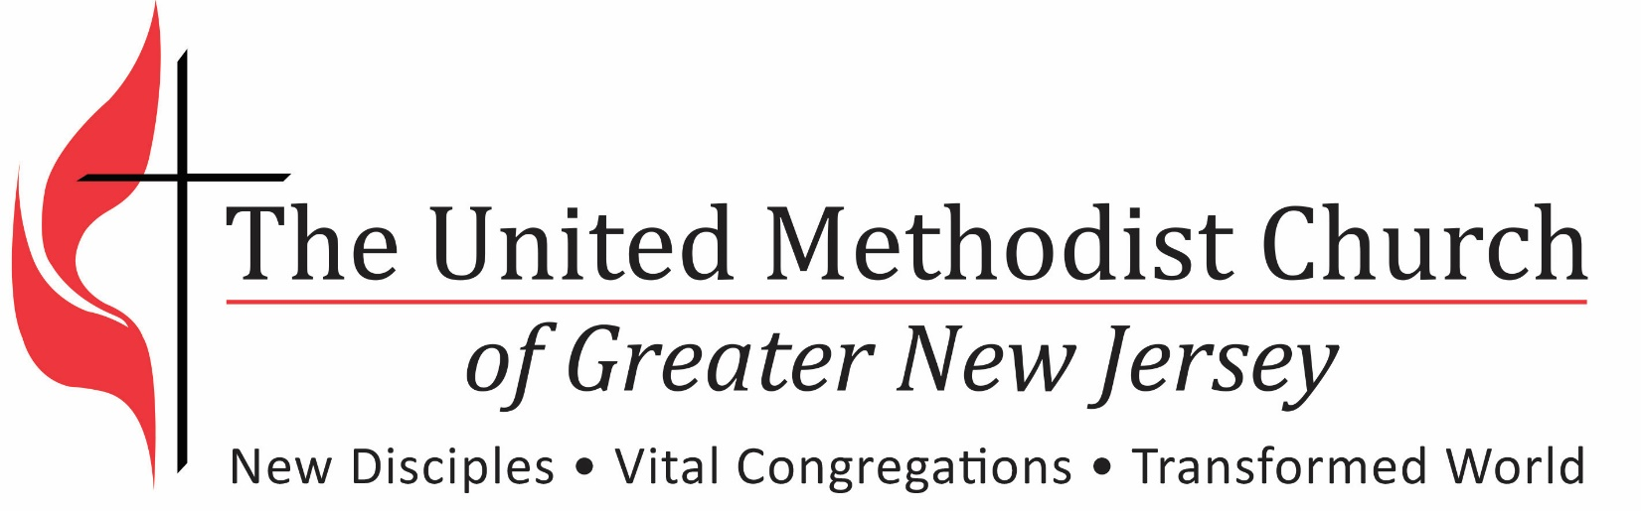

2017 Quarterly Check In
Pastoral Transition Process
Quarterly Check-In Report
(Please Return Electronically to Your District Office)

Important:
Pastor and S/PPR will complete and submit separate Quarterly Check-In Reports.
Please submit the first Quarterly Check-In Report on 9/30/2017 and at the end of each quarter thereafter to the Regional Office.

Report Completed by: (Check one) _____ Pastor _____ SPRC

Church Name:
pastor name:
S/PPR name:

Place the number that appropriately corresponds with your view.
Rate as follows: (1) Strongly Agree; (2) Agree; (3) Disagree; (4) Strongly Disagree

Evaluation Area | 9/30/17 | 12/30/17 | 3/30/18 | 6/30/18 | 9/30/18 | 12/30/18 | 3/30/19
Understanding and Relationship Building
A sufficient number of introductory small group meetings have been held with laity.
The Pastor has conducted one to one meetings with key church leaders.
The Pastor is connecting well with the congregation(s).
Expectations
Fruitful conversations with SPRC and Church Council have been held about expectations.
The Pastor understands the expectations of the congregation.
The Pastor is meeting the church’s expectations.
Initial six month objectives were set and are being worked on or are completed.
12 month congregational goals have been set for the up-coming calendar year.
Progress is being made on the 12month goals.
12 month goals are appropriate for moving the church towards vitality.
Quarterly evaluations have been completed in a timely manner.
Fruitfulness
Worship attendance is growing.
We are seeing more visitors.
More people are attending small group and Bible studies.
More people are engaged in community ministry.
Giving has increased.
Comments: Please enter below, including date.

