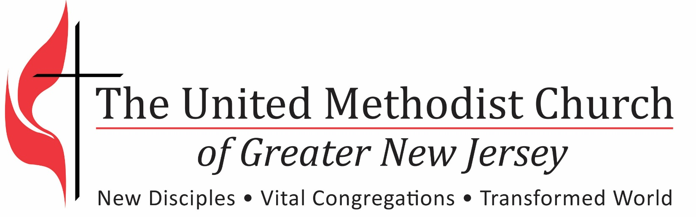

2017 Assessment and Commitment
Pastoral Transition Process

2017 Transition Workshop Assessment and Commitment

- What particularly helpful information and insights have you gained in the workshop?
- From the handout:
- From the speakers:
- From our table discussion:
- From your own reflection:
- What do I commit to share in my local church?
- In our transition team:
- In the larger congregation:
- With my current pastor:
- With our incoming pastor:

