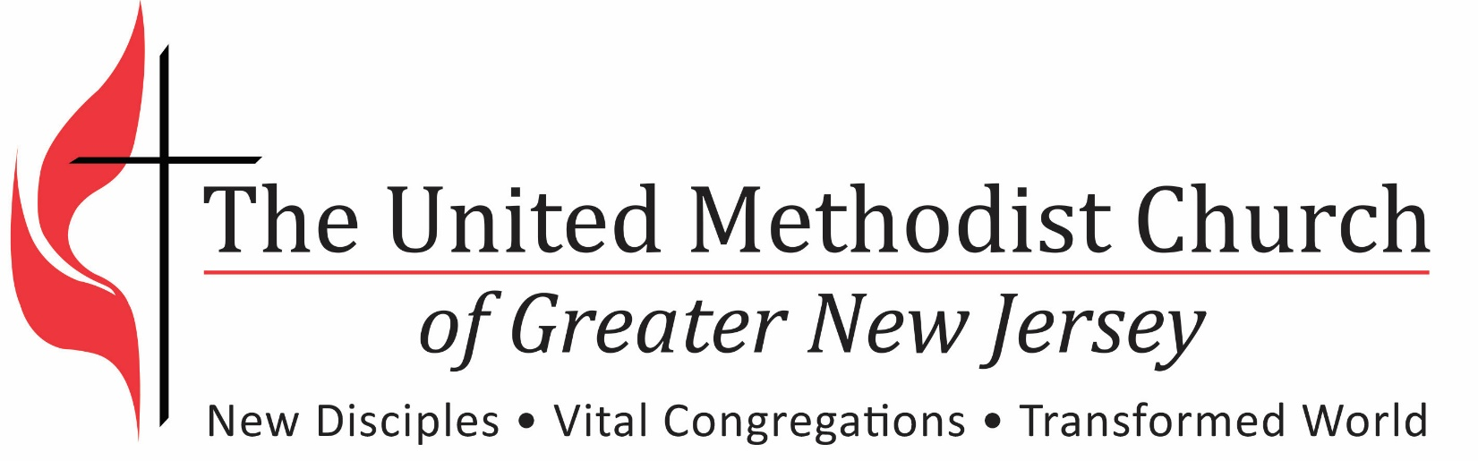

A History Sharing Experience
Pastoral Transition Process
A History Sharing Experience
An interesting experience in a congregation that has received an incoming pastor is a time for history sharing. It is a time for persons in the congregation to gather, to share stories of their life together, and to reflect on what it means for the congregation at this time. It makes a great fellowship activity. Such an experience can be helpful to the church and the incoming pastor in several ways:
- It assists the inclusion process. The pastor becomes one of us when he/she knows our stories.
- Key events in the life of the church are shared.
- Insights into past successes and failures are gained.
- One learns who are the pastors of the past and who in particular is the one by whom the current pastor will be judged.
- Assists the incoming pastor and leaders to assess what the meaning of all of this is for the congregation.

Arrangements:
- About a three-hour block of time is desirable for discussion.
(It always goes well with a potluck supper.)
- Have a listing of previous pastors and dates available.
- Put up a 20-foot length of newsprint that can be used to create a time line. Have a newsprint pad in addition for recording reflections.

Process:
- Enter the dates and pastors across the top, allowing enough room for writing information below their names.
- Questions to ask the group include:
- What are the most important happenings when each pastor was here?
- What are the implications of the successes, e.g. a new worship service?
- How do the failures affect us today?
- Where are the high points in the congregation’s life? The low points?
- When this has been done you want to probe for meaning statements. This can be done as a total group if it is small. Otherwise, have them break into groups of 6-8. Collect the following responses on newsprint.
- General observations
- What do you make of this?
- What concerns you?
- What tells you who you are?
- What are your key strengths?
- What should be a part of your future?
- If the group has done “c” well, you may want them to try to prioritize the meaning statements. It becomes part of the process to come to terms with their history.
- What does this say about our future?
- Develop goals to build on our strengths – stretch toward new ministry.
- Develop strategies to overcome weaknesses – let go of what doesn’t work.

